Issue No. 1 January 2012

We have been delighted with the response to the proposed England Netball Supporters Club and this communication is the first Newsletter to update you on progress so far and to thank you for the interest you have shown in this venture.

A little background regarding the formation of this Supporters Club – many people in England follow our girls around the world, especially to World Championships and Commonwealth Games. In New Zealand in 1999 approximately 200 England supporters travelled to the World Championships and during the preliminary rounds we were all able to sit together but for the finals we had to sit in our purchased seats, consequently we were scattered around the arena. Last year, in Singapore, we were quite few in number, without supporters’ kit, and dotted around the arena, making no real impact when supporting our team! I purchased 3 tickets 12 months before the event, but was off the back of the court! Australia, New Zealand, and even South Africa had huge numbers of supporters, with a travel agent with buying power, and had all the best seats! So we need to do something to ensure we’re there in force and in prime positions, with a sense of identity!

Some of you have kindly offered assistance with the organisation of the Supporters Club and those who ‘ticked the box’ and added the skills they could bring to the group are being contacted for a Conference Call early in February to start the ball rolling. We are also in close communication with England Netball regarding travel agents, promoting the Club and events on a ‘user friendly’ slot on the EN website, potential sponsors etc., etc.

We are hoping to be able to launch the Supporters Club at the Fiat SuperLeague Finals over the weekend of the 19/20th May and we will be in touch with more details nearer that date. Would you like to let us have your views on what you want from a Supporters Club? Simply click ‘reply’ to this email and get in touch, before the 1st Feb. We really do want to hear from you – after all this is going to be your Club!

Meanwhile, here are some dates for your diary – some at home, some abroad, some near, some far. So if you’re looking for some exotic holidays – you could schedule them around supporting our England teams :

2012
European Championships
9 – 11 March | Netball Europe Under 17 Championships | Kelvin Hall, Glasgow, Scotland
9 – 11 March | Netball Europe Under 21 Championship | Antrim Forum, Antrim, N Ireland
25 – 27 May | Netball Europe Open Championship | English Institute of Sport, Sheffield
8 – 10 June | Netball Europe Netball Festival | Gibraltar

Fiat SuperLeague (plus of course all the SuperLeague fixtures)
19 – 20 May | Fiat SuperLeague Finals | Mayesbrook Arena, Barking, London

England Test Matches (TBC)
10 April  12 April  14 April | 3-match Test Series England v Barbados | Birmingham  Bath  Surrey

England Test Matches (TBC)
September | 3-match Test Series England v Jamaica  Based around the EN AGM and Goalden Globes | tbc

World Netball Series (FastNet)
9 – 11 Nov | World Netball Series (FastNet) | New Zealand (Auckland)

2013
England Test Matches (TBC)
Jan / Feb | Tri-Series – England v Australia v New Zealand | Tbc
2014
Commonwealth Games
23 July – 3 August | Commonwealth Games | Glasgow, Scotland
2015
World Netball Championship
9 – 16 August | World Netball Championship | Sydney, Australia
2018
Commonwealth Games
tba | Commonwealth Games | Gold Coast, Australia

As you can see, some exciting times ahead and plenty of opportunity this year to support our England team on home ground.

As soon as we have more information to share with you we will send out another Newsletter but please spread the word about the Supporters Club and do get in touch if you have any questions.

Regards from Pat Haden and Joan Mills

 | 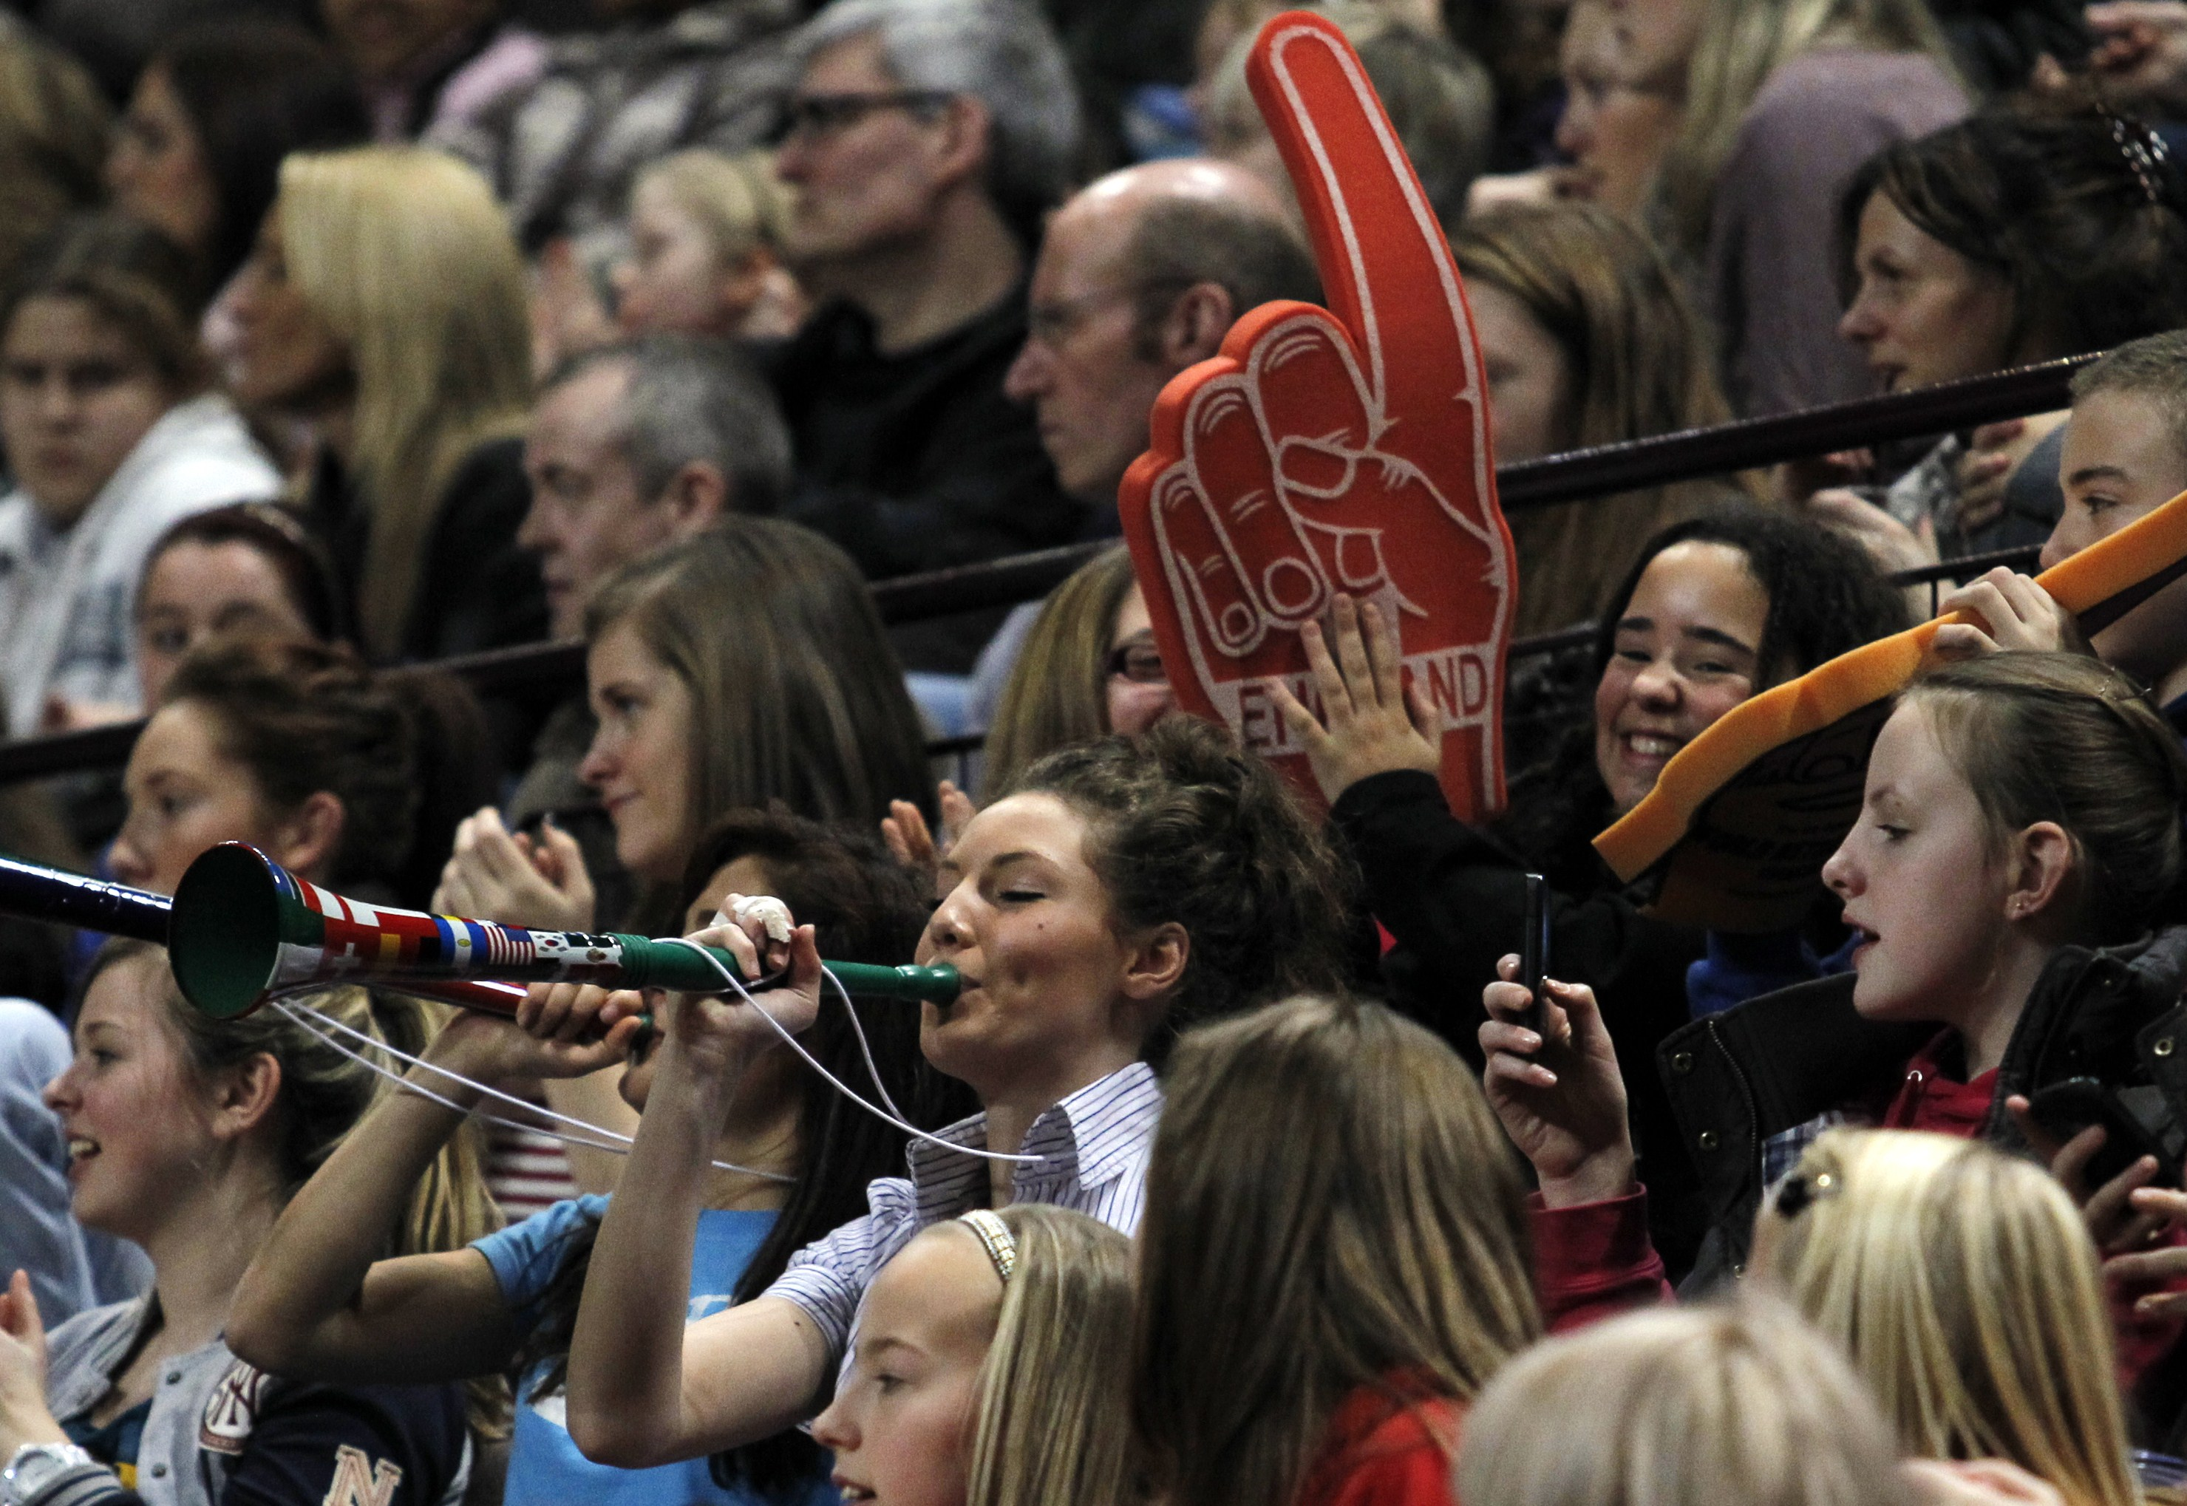 | 

