Issue No. 11 April 2013

Following their fantastic 3-0 test series win over the Aussies earlier this year, England travelled to Jamaica for a 3-match test series against the Sunshine Girls. But the sun definitely shone for our England girls with another 3-0 series win, beating Jamaica 53-42 in the 1st test, 50-45 in the 2nd and 50-36 in the 3rd and Rachel Dunn won her 50th cap in the opening match.
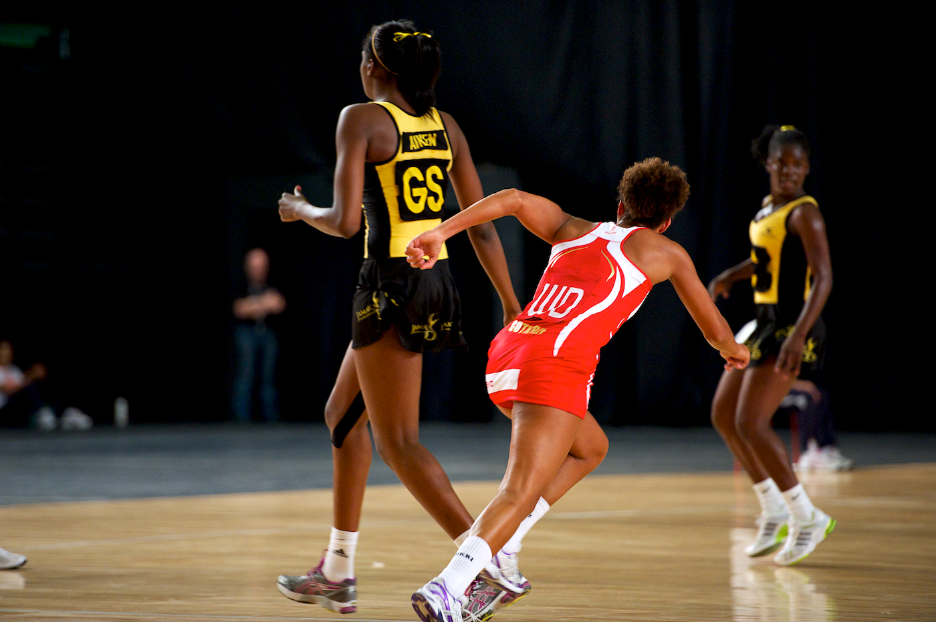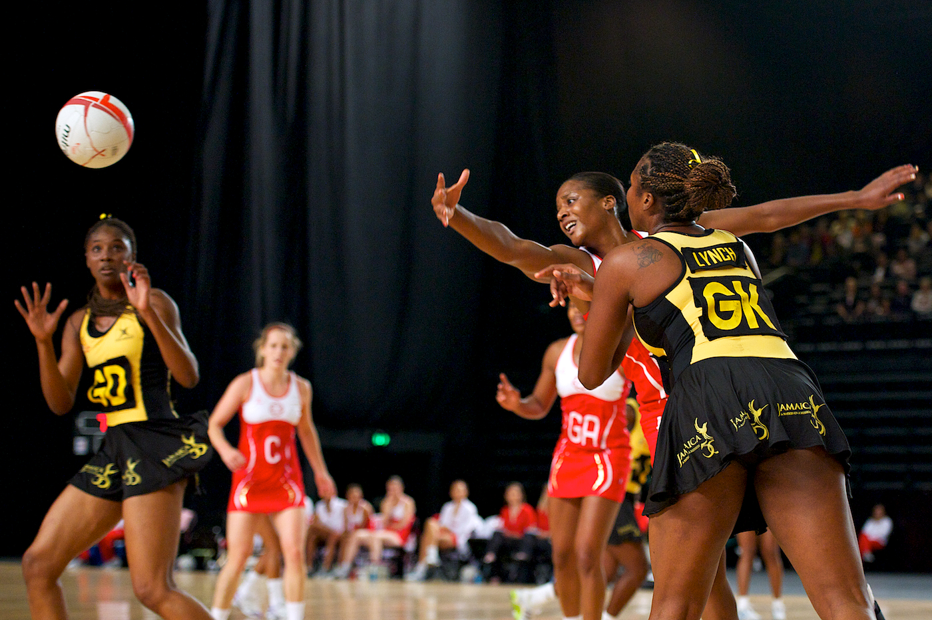

Australia and New Zealand were following the series with interest and now realise that the win over Australia was not just a one-off and that England are definitely contenders for the number one slot!

England hope to have a home test series v South Africa later this year, so watch this space – we will keep you up to date with dates, venues and ticket information.

WORLD YOUTH NETBALL CHAMPIONSHIP
International Netball Federation President, Molly Rhone, travelled to Scotland to carry out the Draw for the World Youth taking place on the 22nd to 31st August at the new Emirates Arena in Glasgow. The twenty participating teams were drawn into four groups of five teams, with the top teams from the 2009 Championship held in the Cook Islands heading up each group :
Group A | Group B | Group C | Group D
Australia | New Zealand | Jamaica | England
South Africa | Trinidad & Tobago | Wales | Barbados
Fiji | Northern Ireland | Cayman Islands | Papua New Guinea
Israel | Bermuda | Samoa | Republic of Ireland
Namibia | Malta | Scotland | Singapore

Attached is the EN Supporters Club accommodation package and you can go to www.worldyouthnetball.com to purchase tickets.
CONGRATULATIONS to Anna Mayes, England Netball’s Head Coach on being selected as one of the UK’s top high performance coaches chosen to be part of the inaugural intake of UK Sport’s World Class Coaching Elite Programme. These coaches have been chosen due to their proven ability to deliver success at the highest level and will benefit from a ground-breaking three-year development programme with access to world leading expertise, technology and experiences.

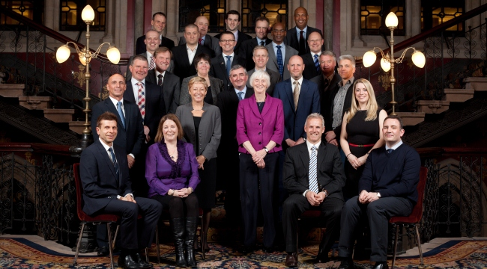 | Anna is not the only netballer in the picture - Liz Nicholl, Chief Executive of UK Sport and Baroness Sue Campbell, Chair of UK Sport, both England Life Members.  Netball’s Women in the top jobs!

Netball Superleague Grand Final heads to Worcester


The 2013 Netball SuperLeague Showdown Grand Final will take place at the brand new University of Worcester Arena on Saturday 25th May, starting at 7pm. Tickets for the event are ON SALE NOW and can be purchased by visiting the Ticketline website on the link below. | 
England Netball affiliated members will be able to receive a reduction on the standard ticket price by calling the Ticketline Sales Hotline on 0844 888 9991. For groups of 15 or more supporters attending the event together, a special price of only £9 for Juniors and £13 for adults will apply. These tickets need to be bought as a single transaction and can be bought on-line or via the Sales Hotline.

For more information about the Worcester Arena visit the website: http://www.worcester.ac.uk/discover/worcester-arena.html

To purchase NSL Grand Final tickets visit the ticketline website
https://www.ticketline.co.uk/order/tickets/13282064/netball-superleague-showdown-grand-final-university-of-worcester-arena-2013-05-25-19-00-00

To purchase tickets via the Ticketline sales hotline call 0844 888 9991. Ticket Cost breakdown

Adult (Member) £15.00 Adult (non-member) £17.50
Junior (Member) £12.00 Junior (non-member) £10.00

Please note: All ticket purchases are subject to a booking fee stipulated by Ticketline.

