Issue No. 2 March 2012

WELCOME to the 2nd Newsletter of the England Netball Supporters Club – we continue to attract interest and are signing up new people on a weekly basis.

We’ve had a conference call with some supporters who have expressed an interest in helping with the formation of the Club and working with England Netball have interviewed travel agents who were keen to become involved. A selection has been made and once contracts have been finalised, we will be able to give you more information.

The first major task for the appointed agents will be to arrange travel and accommodation to the World Youth Netball Championships being held in Glasgow in 2013 (22nd – 31st August) and that will be rapidly followed by the Commonwealth Games, again in Glasgow in 2014 and of course the World Netball Championship in Sydney, Australia in 2015 – and the way time is already flying this year, that is not too far away – so start your tour fund now!

We were going to launch the Supporters Club at the SuperLeague finals in May, but following discussions with England Netball are now looking to the proposed Jamaican Test Series in September this year. However, we are hoping to organise an informal get-together at the SuperLeague final and we will circulate more details nearer the time.

SO MANY OPPORTUNITIES TO WATCH YOUR ENGLAND TEAMS OVER THE NEXT FEW MONTHS :

APRIL 2012
INTERNATIONAL NETBALL SERIES – England v Barbados in Birmingham, Bath and Guildford!
England are currently ranked third in the world and will be favourites to secure more success over their Caribbean counterparts who are in ninth position in the rankings. This will also be the first time that Head Coach Anna Mayes will lead her side in a home international as preparation for the Commonwealth Games in 2014 and World Championships in 2015 begins in earnest.

The Bajan squad will undoubtedly bring some Caribbean flair to the Series, in what promises to be a trio of matches full of colour, style and passion. It is great opportunity to watch your heroes in action and feel the full of excitement of witnessing international netball live!

Tuesday April 10th: England v Barbados, LG Arena (NEC) Birmingham, 7:30pm
www.lgarena.co.uk/whatson/international-netball

Thursday April 12th: England v Barbados, Sport Training Village, University of Bath, 7:30pm
http://www.ticketline.co.uk/international-netball-series#tour

Saturday April 14th: England v Barbados, Surrey Sports Park, Guildford,3pm
SOLD OUT

Tickets are in high demand for this series so be sure to book early!

MAY 2012
FIAT SUPERLEAGUE FINALS
Saturday 19th and Sunday 20th May at the Mayesbrook Arena, Barking, London. No information available yet but we will circulate details as soon as these become known.

NETBALL EUROPE – OPEN COMPETITION
English Institute of Sport, Sheffield
Friday 25th May: 6.00pm England V Northern Ireland
9.00pm Wales V Scotland
Saturday 26th May: 2.00pm England V Wales
4.00pm Northern Ireland V Scotland
Sunday 27th May: 10.00am Wales V Northern Ireland
12 noon Scotland V England

Ticket prices £9 adults and £6 concessions IU18’s and OPA’s)
For tickets contact netballeuropetickets@englandnetball.co.uk

INTERNATIONAL QUAD SERIES in Australia and New Zealand

If you’re heading down under later this year, why not combine your trip with supporting our England team when they play in an International Quad-Series against Australia, New Zealand and South Africa. The series features six double headers with three played in Australia and three in New Zealand. Tickets will be available through Ticketek from Thursday 26th July at www.ticketek.com.au

16/17 September Australian Diamonds v New Zealand Silver Ferns Melbourne, Australia
20 September New Zealand Silver Ferns v Australian Diamonds Auckland, New Zealand
23 September New Zealand Silver Ferns v Australian Diamonds Canterbury, New Zealand
14 October Australian Diamonds v ENGLAND Adelaide, Australia New Zealand Silver Ferns v South Africa
17 October New Zealand Silver Ferns v ENGLAND Newcastle, Australia Australian Diamonds v South Africa
21 October New Zealand Silver Ferns v Australian Diamonds Sydney, Australia ENGLAND v South Africa
25 October Australian Diamonds v South Africa Wellington, New Zealand New Zealand Silver Ferns v ENGLAND
28 October Australian Diamonds v ENGLAND Invercargill, New Zealand New Zealand Silver Ferns v South Africa
1 November ENGLAND v South Africa Hamilton, New Zealand New Zealand Silver Ferns v Australian Diamonds

As soon as we have more information to share with you we will send out another Newsletter but please spread the word about the Supporters Club and do get in touch if you have any questions.

Regards from Pat Haden and Joan Mills

 | 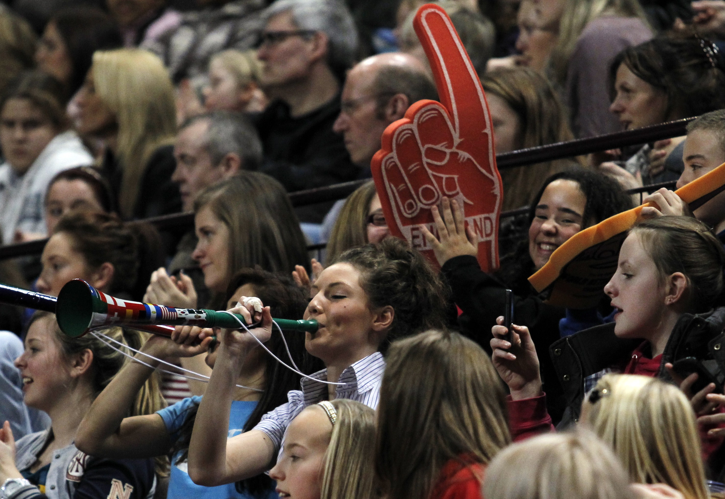 | 

