Netball Archive – How to get Started
Introduction - Today’s Event is Tomorrow’s History.
Netball at any level needs to know its history and where it is stored. So do you know who holds your region, county, league, club archival material? Do you know when you first were formed? Has anyone got a garage, loft etc full of netball stuff? Why not collect it together and create your own archive?
England Netball went from here > > > > > > > > > > > > > > > > > > > > > > > > > to here?
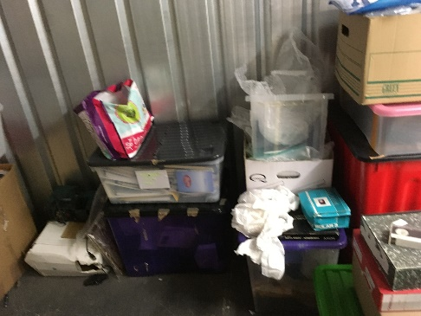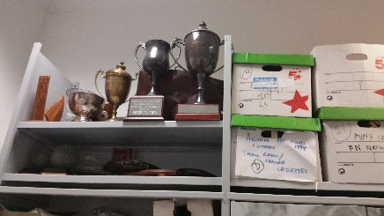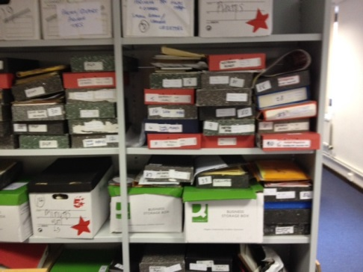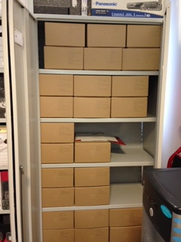
Then finally to here at Heritage Quay (Huddersfield University)
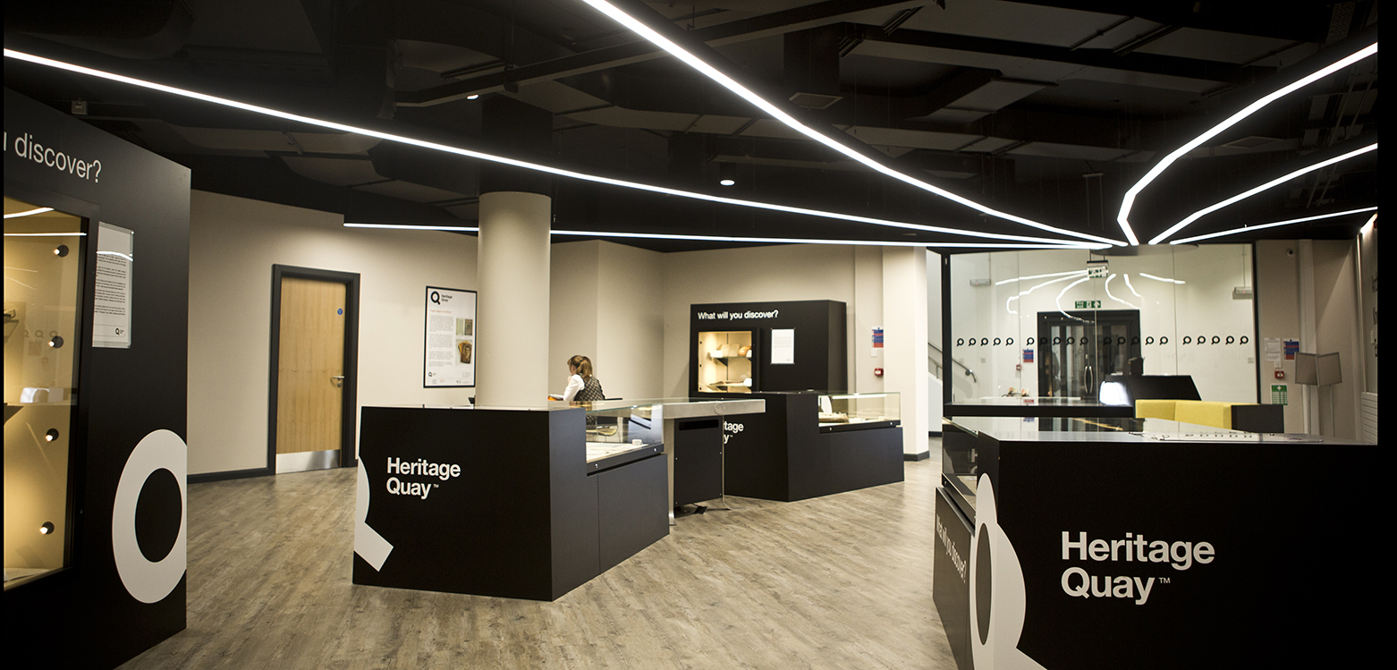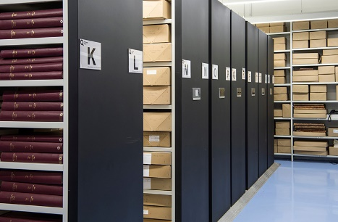

Kent went to the Osterberg Exhibition at Dartford.
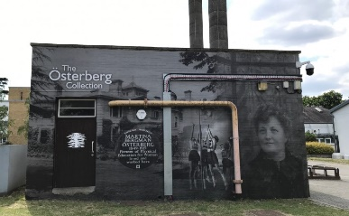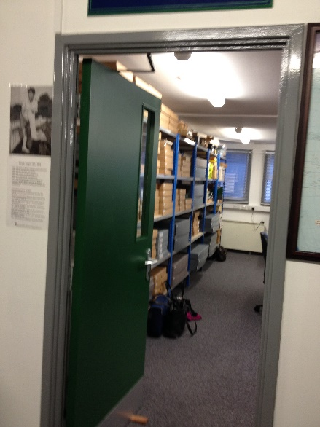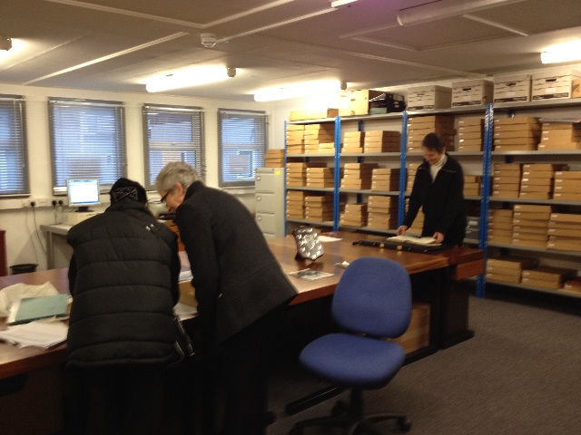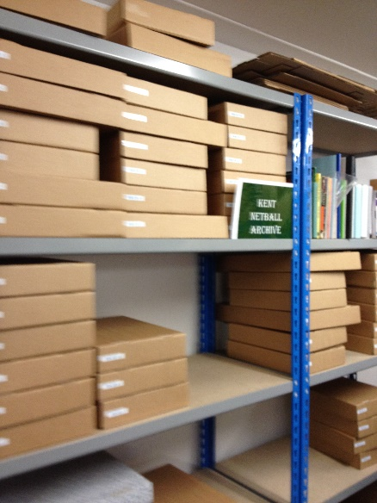

With this in mind, don’t be daunted by the above photographs. You will find your own local archive partner. England Netball wants to encourage clubs, leagues, counties and regions to celebrate England Netball’s 100th Anniversary in 2026, and tell the world what we/you have been doing and when.
So how to get started so that you can create a simple archive with your amazing stories, photos, memories of your netball life, your netball legends, etc? Why not take a look at the England Netball Heritage website – www.ournetballhistory.org.uk – to see what can be achieved.
Following is a very simplified Tool Kit on How to get Started and is aimed at regions, counties, leagues and clubs who want to create their own local archive. This is intended to show you how to get started with the more complex stuff coming along later as you get into creating your archive. Of course questions can be asked on this initial stage by emailing ournetballhistory@englandnetball.co.uk

SO WHERE DO YOU START
- First and foremost you need at least a couple of interested and passionate individuals to form a small work group, preferable with the approval of your organisation who might be able to offer some funding for materials, etc. You will begin to widen out into a local network and it recommended that there is a lead person of the group to make administration easier and provide a single point of contact.
- Focus on your organisation. It is too easy to get side-tracked into related organisations.
- Find out who has what and where it is currently held – as already said is it in a loft, a garage, in boxes etc? Find out Who has got it – are there several members in the club, league, etc who might hold archival material? How much is there? Have you got things like this?
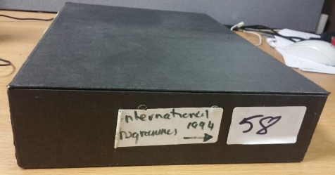
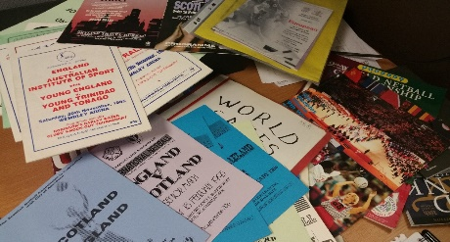

Questions like “Who owns the material?”, “Where did it come from?”, “Do you have permission to use it (i.e. copyright and/or data protection)?”, answers will be given in the fuller version of the Toolkit at a later date.

Once you have been able to ascertain the information in the above 3 questions, this is where the fun starts!! Once you know what you have got you need to make an inventory of it all. Here there is always one simple rule and that is - “To include as much information as possible – When, What, Who, Where and sometimes Why”.
Making an inventory can be as easy or as complex as you like, so when starting out why not just use a simple excel spreadsheet. From that you will then be able to create more details about your organisation
- When did your organisation start, founder members, officers through the ages, who are the leagues today, affiliation player numbers, clubs affiliated, what competitions did you start, squad members over the years (if relevant), AGM dates, awards made (When, for What to Whom), etc. Writing this may well be a document in its own right as an archive document.
The table that follows is just an example. It is based on a possible County breakdown. At the top level there is the County itself. Then there are the sub-committees followed by people past and present. The county will have held events – past and present. Remember the Inter-County tournaments the county will have participated in, and the players who represented the county. Then possibly the county operated academies and the players who participated. There will be photographs, Minutes, articles, programmes, constitutions, etc.
The code used in this example is ‘BDF’ which denotes Bedfordshire from the Chapman Code for counties - https://en.wikipedia.org/wiki/Chapman_code, but it can be whatever you find helpful to denote who you are. One point to remember, this code is used across the whole table and so keep it short. You may wish to have other codes for other themes, as shown here – CC for County Committee, P for People, etc. They are whatever is useful to you. There is an example of items recorded – AGM Records. Also note the convention for dates.
Main Group |  | Sub-Group
Code | Description | Code | Description | Item Date  yyyy-mm-dd | Item Description
BDF/1 | County Committee | BDF/1/CC/1 | County Committee Minutes
 |  | BDF/1/CC/2 | AGM Records | 1958-07-28 | AGM Minutes
 |  |  |  | 1959-07-05 | AGM Minutes
 |  |  |  | 1960-07-19 | AGM Minutes
 |  | BDF/1/CC/3 | Constitutions and Rules
 |  | BDF/1/CC/4 | County Awards
 |  | BDF/1/CC/5 | Communication with Region
 |  | BDF/1/CC/6 | Communication with England Netball
BDF/2 | Sub-Committee Records | BDF/2/SR/1 | Officials TSG
 |  | BDF/2/SR/2 | Coaches TSG
 |  | BDF/2/SR/3 | Leagues TSG
 |  | BDF/2/SR/4 | Volunteers TSG
 |  | BDF/2/SR/5 | Publicity TSG
 |  | BDF/2/SR/6 | Schools TSG
BDF/3 | People | BDF/3/P/1 | County Legends
 |  | BDF/3/P/2 | Individual Officers
BDF/4 | County Events | BDF/4/CE/1 | Inter-county tournament
 |  | BDF/4/CE/2 | County Academy
BDF/5 | Photographs | BDF/5/P/1 | Scanned prints
 |  | BDF/5/P/2 | Digital photos
BDF/6 | DVDs, CDs, memory sticks | BDF/6/D/1 | DVDs
 |  | BDF/6/D/2 | CDs
 |  | BDF/6/D/3 | Memory sticks

Apply the Codes you have defined in your Framework. Collect as much information as possible against each coded item. Ask older and past members for their memories. Don’t leave it too late. Ask them what they remember about the early years of Netball? When did they get involved? What schools and clubs did they play for? And what leagues, counties, regions, and even England?
There will be event programmes, competition results, statistics perhaps, photos, press cuttings, videos, digital minutes and records, etc. England Netball stores the information by format - e.g. all programmes together, all photographs together, press cuttings together etc. The other way is to keep all material for an event say together. There is no ‘right’ way and so think about what works for you. File in coded folders to keep material separated and log onto a spreadsheet (these can be searched easily).
Ensure digital material is backed up in at least one other place – e.g. a copy on the computer, another copy in the ‘cloud’, another on a CD in somebodies house. Remember to review these copies from time to time.
SOME DO’S AND DON’T TO HELP THIS INITIAL PROCESS
DOs | DON’Ts
Store what archives you have found somewhere that is ideally cooler and drier. | Don’t store in a loft or garage as these places are damp and cold in the inter and very hot in the summer.
Keep materials away from food and drink, animals, and water sources.
Always use soft pencils (2B/4B) to label items. | Do NOT use biro, pen or ink.
Only use Brass paper clips if needed, but preferably remove them. | Don’t use adhesives (Sellotape) directly onto an archive or pens, Tippex etc
Use boxes for protecting files and folders as they store easily. Acid free boxes will be needed eventually but not in these early stages.
Make sure files and papers are tidy and fit well within folders and folders fit well within boxes. Not every single piece of paper needs its own individual pocket – just make sure that several sheets are inserted neatly into the pocket.
Lever arch files can be suitable even though they might not be best practice. Better to have 3 or 4 hole binders – 2 hole don’t support the material sufficiently.
If not using proper archival folders or boxes go for undyed folders (whilst coloured folders look nice if they get wet colour may leak onto your papers).

To minimise handling papers, photographs, etc. these can be set in plastic pockets. Modern ones brought from stationers are not proper archival quality but it is very unlikely that they would cause damage and in many cases can be better to use them rather than leaving an archive exposed.
Bundle photographs if you wish and use an envelope of the right size. Or tie them together. Consider putting card on top and bottom to protect the surfaces from the string. The card can also be used to label the bundle. | Do NOT use elastic bands.  Don’t tie too tightly.
Photograph prints – touch at the edges and not on the surface and scanning is a useful tool to use to create a digital version.
Minimise handling delicate material. | Don’t expose papers to bright lights for long periods of time.
Posters can be rolled with a suitably sized piece of paper around them for protection

So that is it. Your knowledge will expand once you start and it is very rewarding. A more in-depth document will follow but there is enough here to get started. The 100th Anniversary of Netball in England is not far away.

