Growing a Netball Archive

As you have accessed this document, then you will have read the How to get Started document. If not, then it is recommended that you do, and here is the link – https://www.ournetballhistory.org.uk/content/category/projects-and-resources/resources
If you have already read it, and have started on your archive journey of creating the archive for your organisation – club, league, county or region, then congratulations.
From the work that the EN volunteer led Netball Heritage and Archive Group (NHAG) has undertaken, you may now have many questions to be answered so that you can progress further. This document is intended to answer some of these questions and follows on from How to get Started. Also remember you can access the Our Netball History website for inspiration - www.ournetballhistory.org.uk.

- Next steps

Assuming you have read Netball Archive – How to get Started, and you are now collecting archive material, no doubt this has created a desire to progress to the next phase and how to grow your Netball archive. That is the aim of this document.

1(a). Perhaps a good place to start is to look at the presentation Making the Most of your Collections – https://www.ournetballhistory.org.uk/wp-content/uploads/2020/09/Making-the-most-of-your-collections-presentation.pdf. This will take you into the realm of the archivist which will be important if you partner with an existing archive or historical society. (Please ignore the last page of this presentation about support for queries and instead email ournetballhistory@englandnetball.co.uk).
From this presentation you will see that:
(i) The Inventory is the Key to the future projects. You will have already started with the simple Excel spreadsheet suggested in How to get Started. Note that the Inventory is different to the Catalogue, which will be defined by your archive partner.
(ii) Making a Plan is essential and some guidance is provided. This should be an extension of what you have already started.
(iii) Advice with numbering, labelling, naming and descriptions. There is some great advice here, but again, tailor it your requirements.
1(b). Some more interesting background information is from a couple of YouTube videos from Heritage Quay, the location of the England Netball archive:
https://www.youtube.com/watch?v=kS2XeaKvIdE&t=26s Part 1 Depositing
https://www.youtube.com/watch?v=gYRHiWi_rZU Part 2 Preservation
Two more videos dealing with Digitisation and Storage of Material are scheduled and will be available shortly.

1(c). Another important step is to enlarge your Netball people with interesting histories and stories section. You may be surprised about the amount of additional archive material this may generate. Ask them to record their memories, either written, or have a recorded interview. Some suggestions for the content are as follows and there is a copy of a template used by England Netball in the Appendices:
How did you get involved, when and where?
Who were your role models and mentors?
Who inspired you?
What school, club, county region and England teams did you play for?
Key dates
Key events
Key milestones
Did you do any coaching and/or umpiring? For who? What qualifications did attain?
If an administrator, perhaps after retiring from playing, what roles did you perform?
What motivates you to still be involved?
What inspires others to get involved?
What was your career and your interests?
If recording an interview, there are two basic methods.
(i) You can record the audio using a software package that allows for editing of the audio sound – good if you want to edit the audio interview.
(ii) The other method is to use a speech recognition software package which translates live, and is probably the most useful for an netball archive. You can then archive the original audio recording as is, along with an edited full transcription and short summary – see below.
If you decide to do manual transcription then from experience these can be very manpower intensive, but can be the best method of obtaining the most accurate information. To make a complete record each recording needs to be edited to provide a coherent and listenable recording, plus an edited 5 minute highlight version. The recording also needs to be transcribed, again with a synopsis.
There is some good oral editing software for any of these methods. It is recommended that you try it out before a live session.
(i) Microsoft Teams has a feature to ‘close caption’ your sessions live. You can then talk and it transfers it into written text (by speech recognition). This can then be downloaded as a text file. It isn’t 100% accurate, and editing and amendment may be necessary, especially if there are broad regional accents, but is far better than having to transcribe from scratch.
(ii) Another package that works with Microsoft Teams is Otter and has a wide range of options, such as cross-conversation speaker identification, good search tools, and mobile apps. In addition it is a recommended FREE piece of transcription software in use with some universities with the link Otter.ai: https://otter.ai/login
(iii) Audacity is good for basic speech editing, with Wavelab Elements or Sound Forge Audio Studio 12 highly recommended, from which manual transcriptions can be achieved. It is possible that there may be a speech recognition software package that could provide text from this edited audio.
1(d) Scanning of photographs to create a digital version is important. A colour scanner is required with a minimum resolution of 300dpi x 300dpi (dots per inch). A higher resolution of 600dpi x 600dpi id even better. Most multi-function computer printers achieve the minimum standard, but it is worth just checking. This resolution is also okay for scanning documents if you can’t obtain ownership of them.
Often there is then a requirement to transfer these digital images and they can be quite large, particularly if a folder of files is to be transferred. This can be achieved with software such as the free WeTransfer software – search using Google.
1(e) Cataloguing can be confusing and there are several methods. England Netball has used a simple tree format as it seemed to fit what was required. Start with the top level groups of your organisation, e.g. Governance and Administration, Competition, Coaching, Officiating, Players, Volunteers, Media, etc. Whatever reflects your organisational structure. Then each of these top level groups may break down into the next layer, and even a further sub-layer. The example from the England Netball - How to get started is re-produced below to give an idea of what is required.
Here you will see a three-digit reference to the organisation, in this case Bedfordshire. This is followed by a number which represents each of the main groups. The sub-group is represented again with a descriptive digit, e.g. CC for County Committee, etc. If there is a further sub-group then these are then numbered. Construct a table of whatever fits your individual organisation.

Main Group |  | Sub-Group
Code | Description | Code | Description | Item Date  yyyy-mm-dd | Item Description
BDF/1 | County Committee | BDF/1/CC/1 | County Committee Minutes
 |  | BDF/1/CC/2 | AGM Records | 1958-07-28 | AGM Minutes
 |  |  |  | 1959-07-05 | AGM Minutes
 |  |  |  | 1960-07-19 | AGM Minutes
 |  | BDF/1/CC/3 | Constitutions and Rules
 |  | BDF/1/CC/4 | County Awards
 |  | BDF/1/CC/5 | Communication with Region
 |  | BDF/1/CC/6 | Communication with England Netball
BDF/2 | Sub-Committee Records | BDF/2/SR/1 | Officials TSG
 |  | BDF/2/SR/2 | Coaches TSG
 |  | BDF/2/SR/3 | Leagues TSG
 |  | BDF/2/SR/4 | Volunteers TSG
 |  | BDF/2/SR/5 | Publicity TSG
 |  | BDF/2/SR/6 | Schools TSG
BDF/3 | People | BDF/3/P/1 | County Legends
 |  | BDF/3/P/2 | Individual Officers
BDF/4 | County Events | BDF/4/CE/1 | Inter-county tournament
 |  | BDF/4/CE/2 | County Academy
BDF/5 | Photographs | BDF/5/P/1 | Scanned prints
 |  | BDF/5/P/2 | Digital photos
BDF/6 | DVDs, CDs, memory sticks | BDF/6/D/1 | DVDs
 |  | BDF/6/D/2 | CDs
 |  | BDF/6/D/3 | Memory sticks

- Partnerships
A useful start is to look at https://www.communityarchives.org.uk/. This is a website for community archives in the UK (Hertfordshire is shown on the interactive map). By panning around the map you can find archives in your area. It is a useful resource of other archives and opportunities to meet other groups. It is possible an archive partner can be found by using the map to identify archives in your area and then approaching them. I suggest you research them first and see what their main theme is and whether sport and recreation is already present. Look at it as an opportunity for them to include sport from a social history viewpoint.
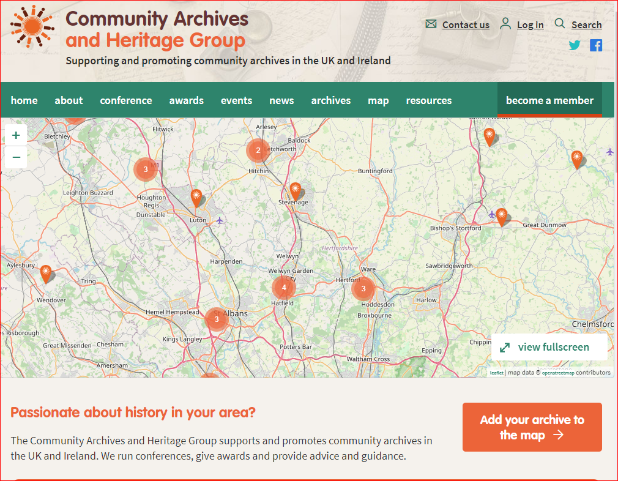

2(a). Before approaching a potential partner pull together some statistics of your archive, both as it is today and what it may expand to. This will give a good idea of the size of your archive and the main categories within it. Costs in archiving will depend on the size and the content of the archive. If they are all digitised then there is little cost involved. If there is a lot of material in boxes, then the boxes need to be proper ‘archive’ acid free boxes, and these will be more expensive. Initially good quality plastic sleeves and three ring or four ring binders from the stationers will suffice.

2(b). When you meet with your potential partner there will be a discussion around:
Costs and who is responsible for what.
What requirements does the archive need for the inclusion of your archive.
Access to your archive – search room, etc.
Agreements for the Deposit and Preservation of Archival Records – the archive will almost certainly have policies and procedures for this.
Updating process is key on how new material will be added and catalogued.
Methods of searching your archive.
What to do with trophies, uniforms, and stuff that is not flat (i.e. a document) or digitised, and anything that doesn’t fit into a box?
- Governance and Forms
The key documents will be an Acquisition Form and a Deposit Agreement. Normally the partner archive will provide these and will be specific to their own organisation. However for background information the Community Archives website - https://www.communityarchives.org.uk/ has some excellent guidance on subjects such as organisation, funding, managing, accessibility, cataloguing, GDPR, digitisation and so on. Really worth a visit.
For your own governance, it will be useful to produce your own document. An example from Kent County Netball Archive Group is attached in the Appendices for reference.
- Sources of Funding
This is an area for research, but one good starting point could be Sporting Heritage who have a funding finder application: https://www.sportingheritage.org.uk/content/advice/funding-finder.
Some local authorities have small grants. Look up their website for clues or just give them a ring.
Some local libraries often can help with funding and equipment. The county council may also have small grants of funding, again look up their website or ring them.

What about your own County or Region? It may be worth asking as they may be just as interested in your Netball heritage.

There are other organisations that sometimes have specific funding opportunities. The Playing Fields Association might be one of them. Charities are also worth researching, particularly those that have social history, or archives as their focus. The National Heritage Lottery is always worth looking at depending on what their main themes are, and if the funding required is quite large, and it is a NEW project, i.e. not started yet - www.heritagefund.org.uk.

- Archive Materials and Suppliers
It will be essential that you use materials that are recommended by archives, museums, libraries, etc. if you are in a partnership with an archive. This includes archive boxes that are acid free and brass wired stitched (brass doesn’t go rusty) and strong enough to be stackable. Paper clips should be brass and markings made with pencil (between 2B and 6B).

Initially good quality three hole or four hole binders and sleeves can be used, available from good stationers.

Suppliers are few and there are some recommendations here:
https://www.ryderbox.co.uk/pages/product-range.
Used by the England Netball archive, large enough to accommodate ring binders (with plastic sleeves), magazines, and other archive items. Two similar sizes, different depth – height x width x depth
Product No. WS263 – 365 x 260 x 100
Product No. WS163 – 285 x 270 x 153
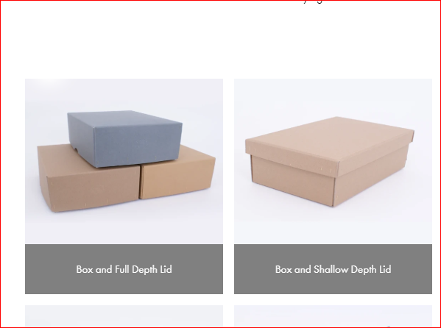
https://www.my-history.co.uk/acatalog/Acid-Free_Storage_Boxes_and_Envelopes-p1.html.
Wide range of products for archiving items. Note that some of the boxes are clam shell rather than separate lids.
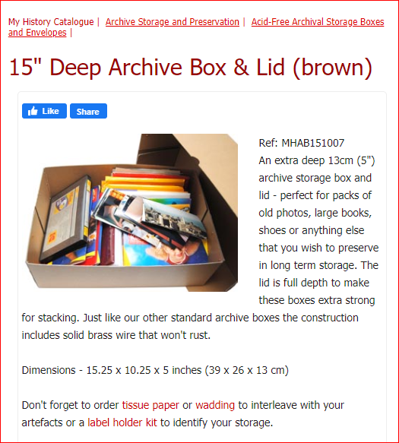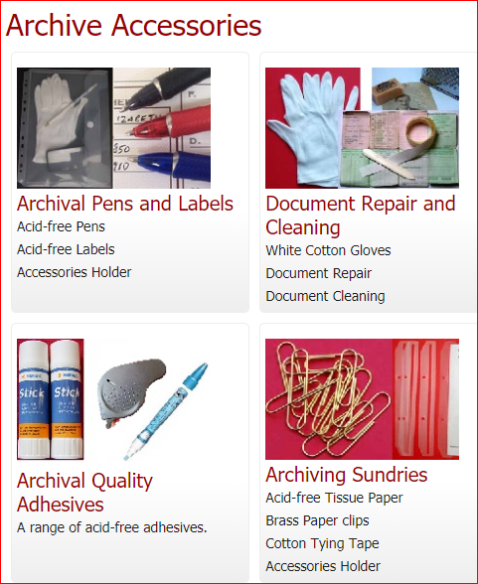
https://www.preservationequipment.com/Catalogue/Archival-Storage
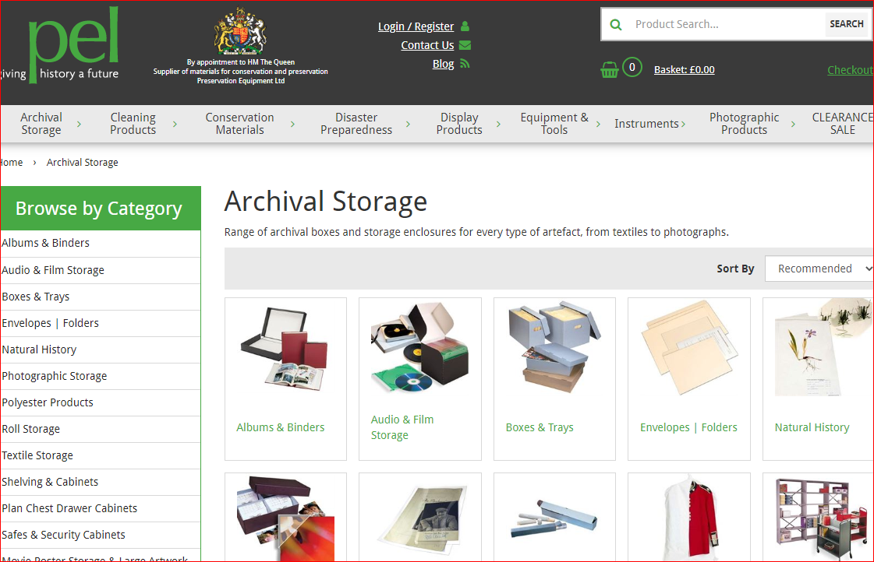
- Promoting Awareness of your Archive
Social media – a Facebook Page specifically for the archive can be very effective as well as useful for getting names and information in a photograph. Twitter and other platforms may be useful depending on what you need.
How about a specific website for your archive?
Place links on the League and/or County and/or Region websites.
Newsletters.
Annual Reports to the County and/or Region.
Articles and reports in your partner organisation promotional material and website.
Offer presentations on your archive to related organisations and activities.
Consider Podcasts and short videos for specific themes.

- References
There is a large range of references but the ones that are relevant to this document are listed below.
http://heritagequay.org/about/. This is the location of the England Netball archive. The website also has useful reference documents under the ABOUT tab/Plans, Policies, Performance & Project, including Acquisition Policy, and Terms and Conditions for Gifts and Deposits. Also click on ‘available online’ and this accesses the Archive Collections Management Policy.
https://www.sportingheritage.org.uk/content/category/advice - Has a number of general How to Guides including a Funding Finder which requires a form to be completed. You can also sign up for the informative Newsletters.
https://www.nationalarchives.gov.uk/documents/archives/archive-principles-and-practice-an-introduction-to-archives-for-non-archivists.pdf – Scroll down to Sections 2 (First steps in archives) and 3 (Next steps in archives) for guidance relevant to this document.
http://sharemuseumseast.org.uk/wp-content/uploads/2013/08/digitisation-FINAL-FULL.pdf - a very detailed document full of useful information about digitisation and CD/DVD/Memory stick life times.

Appendices

A Kent County Netball Archive Group Governance document

B England Netball Heritage and Archive Group Notable Member Template

 | REGULATIONS, AIMS and OBJECTIVES
1. | NAME  The Group will be called The Netball Archive Group (hereinafter called The NAG).
2. | BOUNDARIES  The geographical boundaries of The NAG shall include the County of Kent (governed by the Kent County Council and the Medway Towns Council) and the London Boroughs of Bexley, Bromley, Greenwich and Lewisham.
3. | AIMS  Netball was devised in 1895 at the Madame Österberg Physical Training College in Oakfield Lane, Dartford, Kent, later to become Dartford College of Physical Education, and now the North West Kent College and part of Greenwich University. In 2005, a blue plaque was unveiled at the College as a permanent sign to commemorate the link between the College and the game of Netball.
 | 3.1 | The Archive Group aim to secure the historical records of Netball in Kent in a safe and professional manner in the Bergman Österberg Union (BÖU) at the North West Kent College in Dartford and to ensure that the Archive becomes an important reference point of history, knowledge and interest in the game of Netball for future generations.
 | 3.2 | The Archive Group aim to safely house the historical records of Kent Netball Association (KNA), currently held by the volunteer workforce in the county, past and present netballers, clubs and leagues. Current and future records will be added to the Archive to ensure that there is a permanent record of the activities of KNA and Netball in Kent.
 | 3.3 | The Archive Group aim to raise funds and make application for grant aid to finance, organise and maintain an Archive worthy of the importance of the game of Netball in the community.
 | 3.4 | The Netball Archive aims to provide scholars, netballers and the general public with an understanding of the culture, heritage and achievements of KNA and Netball within the clubs and leagues in Kent and also within the wider community of Netball in England.
 | 3.5 | To allow access to the Netball Archive, by appointment or on open days, to all interested parties and particularly to educational establishments and individual students studying the history of sport and Netball in particular.

4. | OBJECTIVES  Contact has been made with the Bergman Österberg Union (BÖU) which are supporting the project by setting aside a dedicated storage area for the Netball Archive within the Bergman Österberg Union Archive at the North West Kent College, in Oakfield Lane, Dartford, in the county of Kent.  The BÖU is providing a ‘starter pack’ of storage boxes and have offered the services of their Archivist to provide training and support to The NAG personnel carrying out the tasks involved. The work will commence in September 2010 and it is envisaged that it will be a twelve month intensive project to establish the Archive and then on-going to update and maintain the Archive.
 | 4.1 | To contact as many netballers as possible to seek the contribution of material relating to Netball in Kent before they are lost forever. These contributions can be made as donations, items on permanent loan, or items on loan for specific exhibitions.
 | 4.2 | To acknowledge in a Register to be kept with the Netball Archive, all contributions made to the collection.
 | 4.3 | To publicise the existence of the Netball Archive through England Netball, (currently the main source of contact for individuals seeking historical information about the game of Netball) the BÖU and the KNA website at www.kentnetball.co.uk
 | 4.4 | To promote by publicity and to educate an interested public of the value and importance of the game of Netball in the sporting world and particularly its influence on female sporting activities and team work.
5. | THE COMMITTEE  The NAG will be administered by KNA Life Members and other like-minded people.
 | 5.1 | The NAG will consist of up to a maximum of five individuals and will appoint a Chairman, Secretary and Treasurer from within The NAG.
 | 5.2 | Three members shall form a quorum.
 | 5.3 | The NAG may invite any person having specialised knowledge to attend any meeting in an advisory capacity without the power to vote.
 | 5.4 | Each member of The NAG shall have one vote.

6. | FINANCES  All monies will be banked in an account held in the name of The NAG.
 | 6.1 | The Treasurer will be responsible for the finances of The NAG.
 | 6.2 | Any cheques drawn against funds should hold the signatures of the Treasurer plus one other member of The NAG.
7. | AMENDMENTS TO THESE RULES AND REGULATIONS  Amendments to these rules and regulations may be made by The NAG as and when they deem necessary.
8. | DISSOLUTION  If at any meeting of The NAG a resolution were passed calling for the dissolution of The NAG, the Secretary shall immediately convene a Special Meeting of The NAG to discuss and vote on the resolution.
 | 8.1 | If at that Special Meeting, the resolution is carried by a least two thirds of the Members present at the meeting, The NAG will proceed to realise the assets of The Netball Archive Group and discharge all debts and liabilities.
 | 8.2 | After discharging all debts and liabilities the remaining assets shall be given or transferred to some other voluntary organisation having objectives similar to those of The NAG.

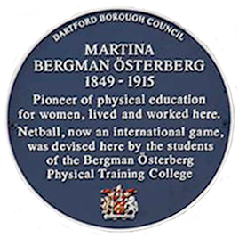
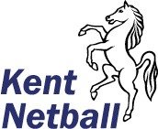
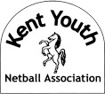
The Netball Archive is located with the Bergman Österberg Union Archive at the Dartford Campus of North West Kent College, the original site of the Bergman Österberg Physical Training College, later Dartford College of Physical Education.

The Netball Archive Group benefits from the following sponsors:

Kent Netball Bergman Österberg Union
Kent Youth Netball Association Kent County Playing Fields Association

MY NETBALL STORY
What is it about netball that makes it such a special part of your life? What motivates you to still be involved?

Name | Club |  |  | County | Region
Please insert a (V) if it was a volunteer role
Question |  | Year | Answer
Who inspired you to become involved and why?

In what capacity did your story begin? Where and When

Who were your role models and mentors?

What roles have you been involved in?

What are the major moments that stick in your memories?

Key events and milestones

Did you do any coaching and / or umpiring, and for who?
What qualifications did attain?

If an administrator, what roles did you perform?

What motivates you to still be involved?

How would you inspire others to be involved?

Interests outside of Netball

Any other comments

Please attach any relevant photos you would like to share, but please include where/when/who

