Article for Sporting Heritage Newsletter
Why does England Netball believe its Heritage is important?
Let me ask a question or two.
Did you know wheelchair Netball was included in the early Olympiads at Stoke Mandeville?
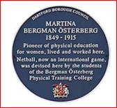
Or that the origins of Netball date back to 1897, no not a typo, at the Madame Österberg College, now North Kent College, Dartford Campus?

How about your perception of Netball prior to the Vitality Roses’ Commonwealth Games GOLD medal in 2018?
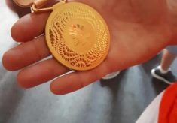
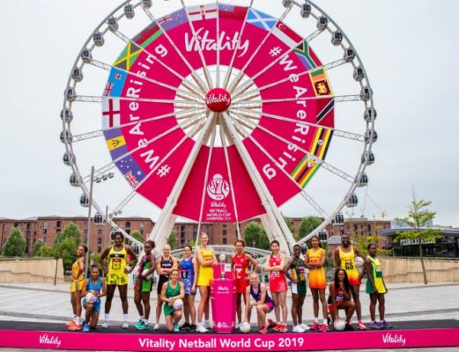
That GOLD medal, won against all the odds on the Gold Coast, Australia, led to the 2018 BBC TV Sports Personality Team of the Year award, plus BBC Greatest Sporting Moment of the Year, and then a year later, the hugely successful Vitality Netball World Cup in Liverpool, saw an explosion in viewing and participation attendance figures across the sport.
Suddenly Netball was in the public consciousness as a modern, athletic and demanding sport.
The public have an insatiable demand for stories relating to sport and after that history making moment in the Gold Coast, and then in the lead up to the World Cup, it was Netball’s turn to be in the spotlight. It led to an unprecedented demand from the media in all its forms for stories, articles, information, statistics, photographs and video. Much of the response to this demand wouldn’t have been possible hadn’t England Netball not supported a small group of volunteers to organise the hundreds of files, folders, boxes, photographs, films and videos collected over the years, into an organised and catalogued archive. We were fortunate to partner with Heritage Quay, University of Huddersfield and their professional archivists to help facilitate our work. Our collection of archive material is housed in Heritage Quay’s purpose-built archive facility. Incidentally, Netball isn’t the only sport housed there.
The message is that without an organised and accessible archive of heritage material, some of the recent great media coverage on Netball’s history across multiple media outlets, wouldn’t have come to fruition.
England Netball is committed to maintaining and growing its heritage. The National Governing Body clearly sees that access to netball’s back stories recorded in print, photographs, and visual media, is vital in supporting their ambitious programme for the future, including the celebrations for the 100th Anniversary of England Netball in 2026.

Board members, staff and volunteers are recognising that Today’s Event is Tomorrows Heritage. By capturing in its archive, a record of key events and decisions taking place today, the learning and research about the game of Netball and its impact can continue into the future.
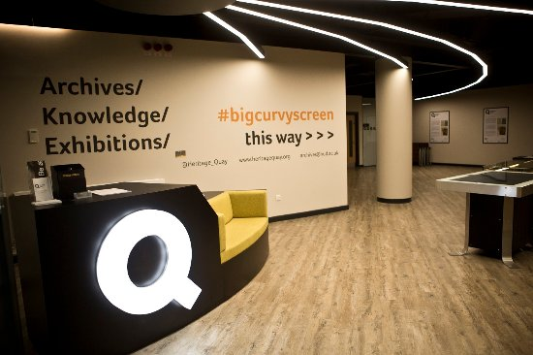
There are already researchers from places such as New Zealand, South Africa, USA and of course the UK, delving into the records. Some of their research is around the social impact of Netball on sport, and women’s sport in particular, and society. Some is on the origins of Netball and its development into today’s modern and competitive team sport. None of this is possible without access to a well organised archive.
Heritage Quay has a search room for access to the extensive amount of hard copy available, including England Netball’s 5th Quarter member magazine that dates back into the mists of time. There are records on individuals in Netball – from Netball pioneers in the early decades of the 20th century, England Vitality Roses of the 21st, and others who have been influential in the wider world of sport – Baroness Sue Campbell DBE, ex-England Netball player, CEO National Coaching Foundation, Chair of UK Sport, Chair of Youth Sports Trust, and currently Director of Women’s Football; Liz Nicoll CBE, ex-Welsh Netball player, CEO England Netball, CEO UK Sport, currently President of the International Netball Federation; Lisa Wainwright, CEO Sport and Recreation Alliance, to name a few. There is a library of old film dating back to the 1960s and videos, the plan is to digitise these to preserve the originals and make them available, and much, much more material.
There is a dedicated website www.ournetballhistory.org.uk which largely contains the photographic material at Heritage Quay, plus many other contributions. There is no doubt that Heritage underpins much of what England Netball does now and into the future.
Today’s Netball Family is a flourishing community and the bonds it has created are strengthened through an understanding of its Heritage.

Brian Worrell
Volunteer, England Netball Heritage & Archive Group.
February 2021

