Introduction
In January 2020, the first case of COVID-19 (coronavirus) was identified in the UK. By March 2020, the UK was in its first national lockdown - which remained in place, on and off, until April 2021.
This account, written by Watford Netball League (WNL) and the Kath Worrell Junior League (KWJL) captures its members stories and experiences of playing, coaching, umpiring, and administrating club netball during coronavirus.
The stories, as requested by England Netball archivists, will be collated and shared with England Netball and via www.ournetballhistory.org.uk.
The following acronyms are used throughout this report:
- EN: England Netball
- KWNL: Kath Worrell Junior League
- WNL: Watford Netball League

January—February 2020

The first case of coronavirus is identified in the UK
On 31 January, the first two cases of coronavirus were reported in the UK. By the end of February, this had increased to 20 reported cases.
Player, Watford Warriors:
“I wasn’t worried about covid as a whole.”
Sara, Flames Netball Club:
“The media covered up how serious it was at this time.”
A coach:
“Didn’t understand about it. Then just before lockdown we noticed indoor matches didn’t shake hands. So our team decided to not shake hands. We didn’t know about the “elbow pump” then and got told we were bad sportsmen for it! Felt totally upset by Watford League organisers- as if we had to know everything!”
An umpire:
“I felt (and it turns out I was right) that players and umpires alike would see the fun side of trying to remember all the do's and don’ts of the new game instead of worrying about everything they had to learn. Everyone learned together so matches were very relaxed.”

March 2020

The UK goes into a national lockdown
At the start of March, there were 200+ reported cases of COVID-19 in the UK and one confirmed death. On 12 March the chief medical officer raised the risk from ‘moderate’ to ‘high’. The prime minister (PM) also advised against non-essential travel and contact with others. A national lockdown, to support ‘stay at home’ measures, was announced by the PM to come into effect on 26 March. By the end of March, the UK was in lockdown and there were 11,000 reported cases of COVID-19 cases and 500 related deaths.
Player, Watford Warriors:
“I wasn’t worried as a whole and for my age group the risk is low.”
Sara, Flames Netball Club:
“(I was) worried about spreading the virus.”
A coach:
“As above we didn’t really know much about it - but for chastised by the league”
An umpire:
“I felt concern(ed)… the rules we had to follow were clear to ensure our safety, although of course any deaths were unfortunate.”

Watford Netball League (WNL):

The 2019/20 season ends (unfinished)
On 15 March, all WNL matches were played as normal. On the following Wednesday, the government announced that schools would close from Friday (20 March). Likewise, cafes, pubs, restaurants, theatres, cinemas, gyms and leisure centres were asked to close also. The impact of the sudden closures in the lead up to the national lockdown meant that WNL’s season ended with three rounds un-played.

Player, Watford Warriors:
“I love playing so I was sad not to play.”
Sara, Flames Netball Club:
“It was a shame but the right thing to be done.”
A coach:
“We were relieved that matches were cancelled. It took the pressure off us as a club to try to not mix or protect. It took the responsibility out of our hands.
We asked to not return. We have teens playing in the adult league and we’re told at the time their numbers were highest. We were trying to protect other teams.”

April 2020

Lockdown continues in the UK
By the end of April, there were 100,000+ reported cases of COVID-19 in the UK and 20,000 confirmed deaths. The UK remained in lockdown over Easter.

May 2020

The government announce reopening plans for the UK
With the national lockdown still in effect, in mid-May, the government announced the first stages of reopening the UK. At this time, it becomes permissible to exercise outdoors only with one member of another household. The Department for Digital, Culture, Media and Sport commence their reviews of how sporting events can resume safely.

Flames Netball Club:

Flames postpone their annual tea party
Flames, an affiliated club to WNL, announced to their members that the annual tea party and awards presentation (scheduled for 17 May), will be postponed owing to the current lockdown. The event was rescheduled for June.

June 2020

Non-essential retailers start to reopen in the UK
The UK remains in lockdown, however, various rules are expanded including gatherings of people from more than one household can meet outdoors in groups of six (early June) and non-essential retailers are permitted to open (mid-June).

Flames Netball Club:

Flames Netball Club run their awards night via Zoom
Many clubs start to adopt video call technology, including Zoom, to run meetings and sessions for their clubs. Flames Netball Club, as an example, ran their postponed May tea party as an evening video call instead.

July 2020

National lockdown restrictions start to ease
From 4 July the Lockdown Regulations were relaxed enabling businesses, including restaurants and hairdressers, to reopen. Leisure centres opened at the end of July.

England Netball:

The roadmap for the return of community netball is announced
England Netball announced the six planned stages for netball to resume. The plan covered the details for phasing in: individual activity (May); small group activity, eg outdoors with six people (June); larger group activity (August); modified training (August); Competition modified rules (September); full training and competition.
Available: https://www.englandnetball.co.uk/about/covid-19-support/community-netball-roadmap/ [Accessed 15 February 2021]

Sara, Flames Netball Club:
“I was happy there were plans to start again.”
A coach:
“We did not (want to) return to matches - it was not an option for us.”
An umpire:
“(Good) Because there appeared to be light at the end of the long tunnel.”

August 2020

Football, with spectators, returns
Brighton host Chelsea in the first football match with a limited number of spectators.

England Netball:

Netball organisers provided further guidance
England Netball announced that netball programmes could resume providing the following measures were in place: appoint a COVID-19 officer; read the Restart Guidance; provide a risk assessment; produce and activate a risk mitigation plan; and have a current partnership agreement with England Netball.

September 2020
Preparing for the season ahead
As clubs and the leagues prepared to restart, coaches, umpires and players were learning the new modified rules, which focuses mainly around four feet spacing at the start of play, four feet marking, four feet positioning for penalised players, the removal of toss ups and no ‘idle’ interactions with other players.

Sara, Flames Netball Club:
“I understood why the new rules were there but was concerned how they would impact the game.”
A coach:
“Why do we now have to use the new rules - it’s too complicated and no one knows about the extra distance. We should wait - let’s not rush back.”
An umpire:
“Happy with that because all changes made perfect sense, especially once explained in the videos.”

The use of technology for training and information sharing
Whilst some players were able to meet up in-line with government guidelines, others used technology to connect with their members. Some clubs held online training sessions. Likewise, club meetings and umpire training were held online.

Sara, Flames Netball Club:
“I struggled to get the motivation to do things from home and didn’t have a lot of floor space (for training).”
A coach:
“Our club has never stopped training - we have been on zoom since day one - 5 sessions a week including arts- for our junior members.”
Shell, Flames Netball Club:
“It’s not the same as face-to-face but meant I could keep in contact with my club. I don’t drive so not having to bus to attend training gave me an hour back!”

October 2020

Local lockdown restrictions in place
At the start of October around one quarter of the UK were in local lockdowns. The government introduced a three-tier system on 14 October. At this point, Watford was not in a local lockdown.
By 31 October, there were one million confirmed cases of coronavirus in the UK.

Watford Netball League (WNL):

The 2020/21 season commences with safety measures in place
The first round took place (for seniors only) on 11 October with the new safety measures in place.
See ‘Watford Netball League safety measures’ overpage.

Watford Netball League safety measures

Arriving (and exiting) the courts for matches
Prior to entering the courts, teams and a coach and/or manager met with their team in the designated meeting area - see ‘1’ on the first image below.

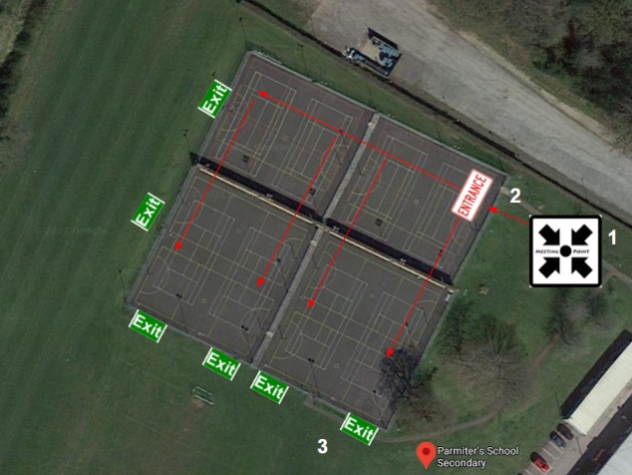 | 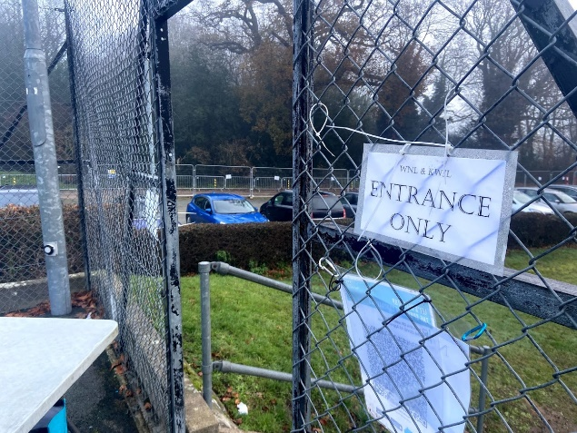
Parmiters School, Watford, court layout | Court entrance point
Teams could enter the courts 20-minutes prior to their match for warm-up, once all team members had arrived. To do so, they would approach the one-way entrance point into the courts - see ‘2’ on the first image above.
Signage was in place to highlight the entrance point, exit points and court numbers.

Managing the entry point / the role of the door monitor
The entrance was manned by a door monitor whose role was to, via the team captain, confirm that no team members had any known symptoms of COVID-19, ensure a team member checked-in using the NHS Test and Trace QR code and ask all players to sanitise their hands on arrival.

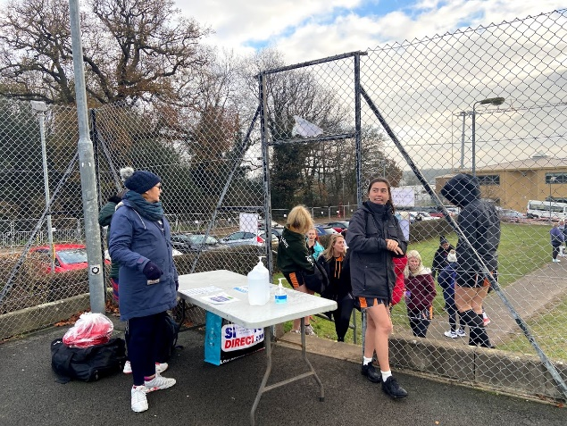  Door monitor managing the entrance point | 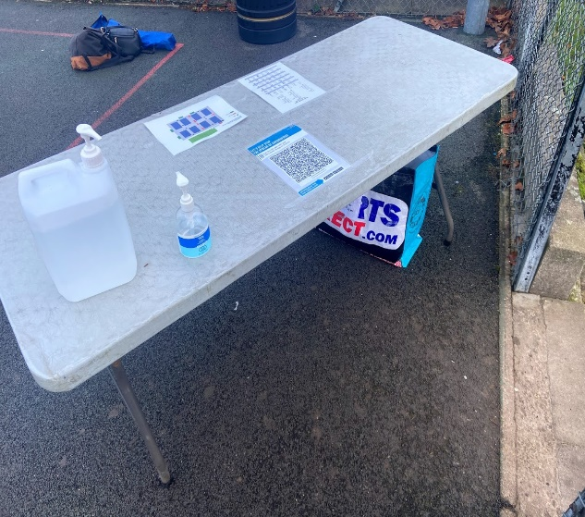  Entrance point table

To support the door monitor, the entrance point was equipped with sanitiser, the week’s fixtures, a court map and the venues NHS Test and Trace QR code. Each club took turns to provide a door monitor.  The entrance was restricted to one team at a time. Permitted access were the team members and their one or two team selected personnel. Each team was allowed three spectators who could watch the match from outside the courts. | 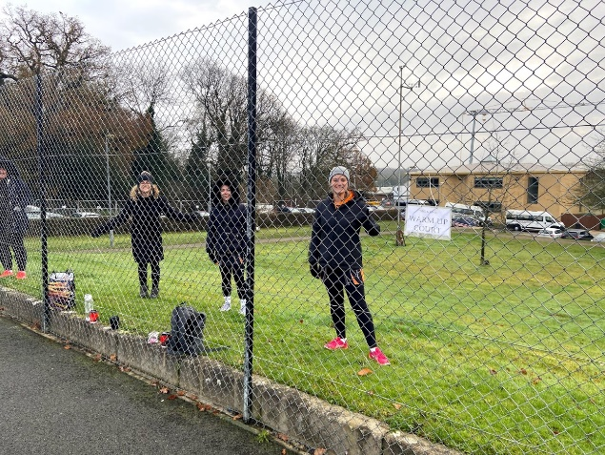  Three spectators per term were permitted

Match safety measures
At the ends of each court, on the fence line behind each goal post, sanitiser wipes were available.
Teams were asked to sanitise the goal post and match ball at the end of every quarter.

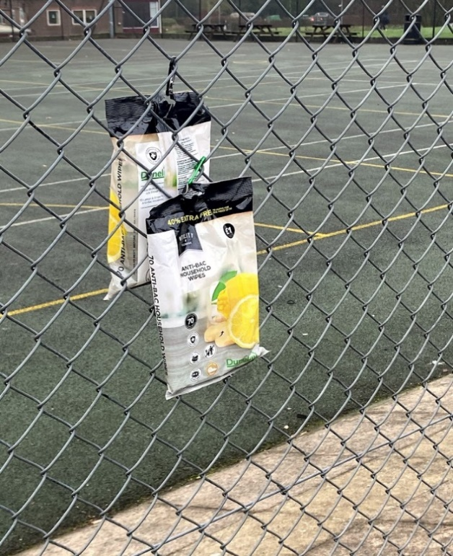  Sanitiser wipes | 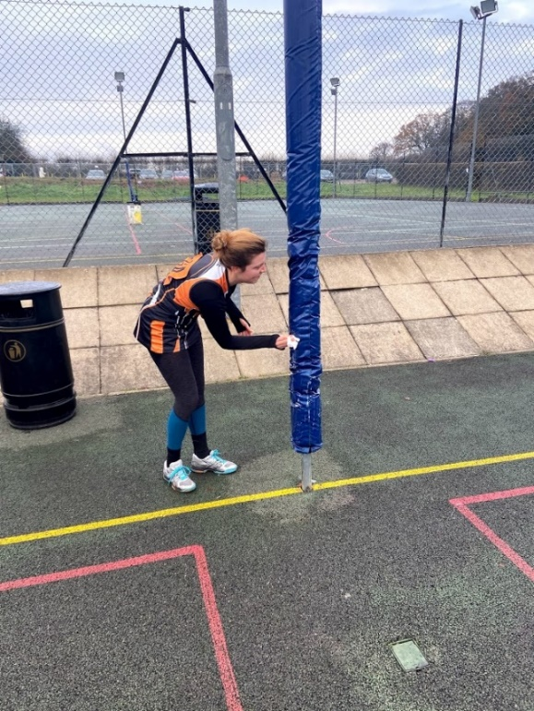  Wiping down the goal post
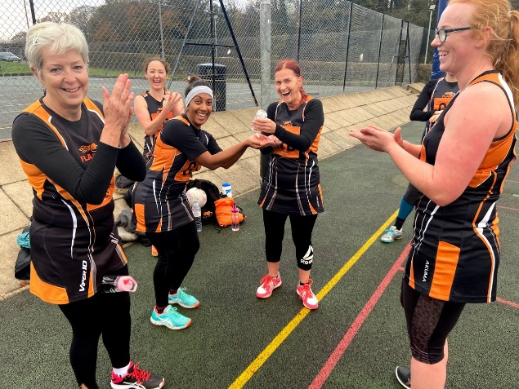  Hand sanitising during the match-break | 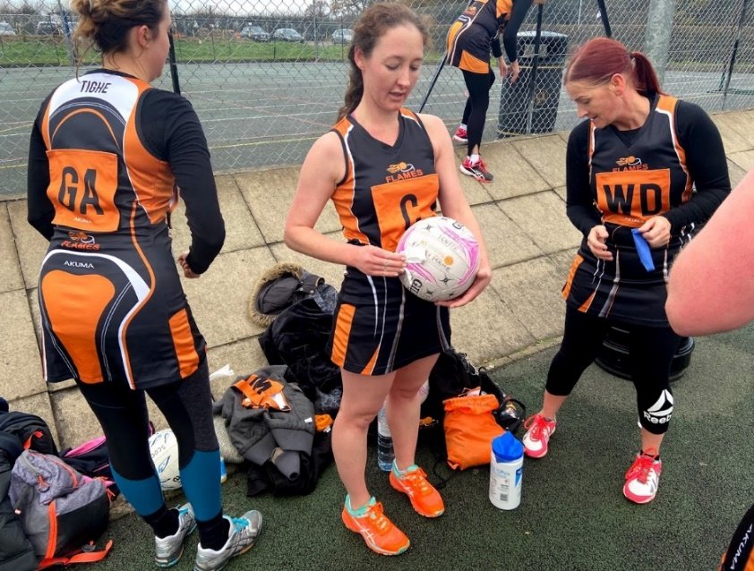  Sanitising the match-ball

Sara, Flames Netball Club:
“I was happy to comply (with the league’s safety measures) as this meant it was a safe environment.
With getting used to the new rules in training it wasn’t an issue playing the match like it. It was so great to be back on court ”
Shell, Flames Netball Club:
“I did a couple of shifts on the entrance door to the courts making sure teams were following the new safety measures. Players and umpires were only too happy to follow the guidelines - everyone seemed excited to be playing again.”

An umpire:
“I was a bit nervous at the start but realised that so much work had gone into the prep for the day's netball to get everything right that I gained confidence that I could do my job safely and efficiently.”
Player, Watford Warriors:
“Happy to play but frustrated that distance rules weren’t enforced more strictly.”

November 2020
England enters its second national lockdown
WNL held its round 3 fixtures on 1 November. By the following Thursday, England began its second national lockdown - again temporarily pausing community sport.

Sara, Flames Netball Club:
“It seemed like we did training and get back onto court for such a short time.”
An umpire:
“Sad and disappointed.”

Kath Worrell Junior League (KWJL):

Postponed until April 2021
Due to start on 8 November, the junior league is postponed until April 2021 due to the lockdown.

December 2020
The second lockdown ends
On 2 December the second lockdown ended with the initial tiers still in place. Watford remained in the second tier therefore netball activity could resume.

England’s tier system revised and updated to include a new tier four
On 14 December the health secretary announced a new variant of coronavirus had been identified.
By the following Saturday the government announced that London, south east and the east of England would go into the new fourth tier from the following day.

Watford Netball League (WNL):

The season restarts with a revised schedule
The WNL played round four on 6 December, and then round seven on 13 December. At this point, round five and six had been scheduled for the new year.

Sara, Flames Netball Club:
“I felt it was a risk attending.”

Watford Netball League (WNL):

Matches scheduled for 20 December to be postponed
The league announced that matches scheduled for 20 December would be postponed to mitigate risks ahead of Christmas for those players bubbling with additional households.

January 2021
The prime minister updates the nation
At the start of January the prime minister announced that coronavirus cases would likely continue to rise. At that point, there were 50,000 daily cases reported. At the end of January, the PM announced that the UK had become the fifth country to reach over 100,000 coronavirus deaths. However, the plan for a phased easing of restrictions would begin in early March.

February 2021
The prime minister announces the roadmap out of lockdown

On 22 February the prime minister announced the roadmap lifting lockdown restrictions. The plan included five main stages including: schools reopening (8 March); two households or six people allowed to meet outdoors (29 March); opening of non-essential retail (12 April); opening of hospitality and removal of most rules affecting outdoor social contact (17 May); and all lockdown limits removed (21 June).

England Netball:

Netball organisers provided further guidance
England Netball announce the proposed spring roadmap for returning to netball. The plan outlined five main stages including: resuming netball in schools (8 March); opening outdoor netball facilities and resuming outdoor netball activity (29 March); opening indoor netball facilities and resuming indoor junior activity (12 April); resuming indoor adult netball activity (17 May); and the removal of modified rules and resuming tournaments (21 June).
Available: https://www.englandnetball.co.uk/spring-2021-roadmap-for-netball/
[Accessed 15 March 2021]

April 2021

Watford Netball League (WNL) re-start
The league announced that matches would restart on April 11th in three Divisions through to May 23rd with a reduced number of teams. Some clubs decided to wait until the new season to start in September with the full rules.

Kath Worrell Netball Junior League (KWJL) re-start
The leagues will restart as a Summer League 25th May for six weeks ending 6th July in three Pools, one for each age group.

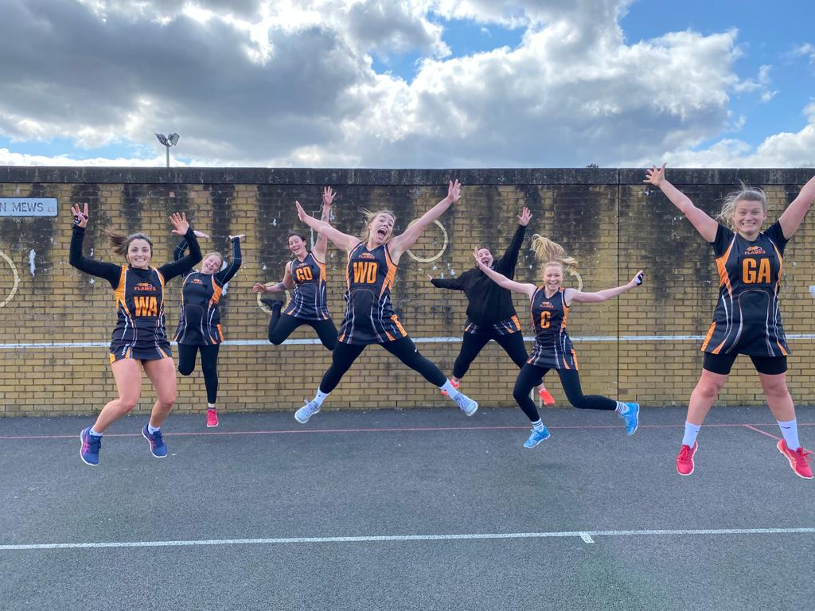

Brian Worrell, President:
‘It is great to see players back on court. I would like to pay tribute to the small group of dedicated volunteers, ably led by Janet Ryan, Chair, who worked through the twists and turns of Covid-19 over 2020 and 2021, to make this happen. I know all the players from both leagues are very grateful.’

Rising again

On any positives from your experience of being a part of community sport during COVID-19...
Shell, Flames Netball Club:
“I think I realised how much I value being a part of club sport, and the community it provides.”
Player, Watford Warriors:
“That I have friends who are not just friends because of netball.”

On concerns for the future of club netball…
Shell, Flames Netball Club:
“I think the next few years may see a decline in memberships - especially if people have been made redundant and, therefore, less disposable income. Also, I think some people may not wish to commit to a membership until a full-season is guaranteed again unfortunately.”
A coach:
“Ours (club) might close.”
An umpire:
“Funding.”

On how this experience could shape netball for the better…
Shell, Flames Netball Club:
“Video calls, could potentially change the way we train and run club meetings - especially where venue access is a challenge.”
Sara, Flames Netball Club:
“Getting together on Zoom is great to keep in touch and all being in the same situation provides comfort.”

Author
Rachelle Anderson
Watford Netball League

More personal stories

Diane’s story
I’m chair of the St Alban’s league, on the Officiating Technical Group (OTG) and have also umpired with the Watford League for a long time.
When the modified rules came out umpires and players have had to get to grips with them. On court - when you’re in the moment and playing - as much as you want the teams you’re umpiring to distance four feet it’s difficult. Also trying to get the teams to not get too close or huddle during the breaks etc.
The majority of players maintain a good attitude on court. Although the players know all the rules, in the heat of the moment you need to keep reminding them. Especially on the transverse line at the centre pass - players getting close and you have to remind them of their distance.
The modified rules are fairly straight forward but then people just forget when they are on court. For example, the goal-shooter and the goal-keeper start chatting because the ball is not up their end of the court and you have to remind them about distancing and that they can’t chat.
There were some misunderstandings about some of the rules. For example, whether you need to be four feet if defending from the side of the player or behind the player. However, it was a learning curve for everybody.
I’ve been to so many Zoom meetings since last summer! There were two sets of rules to get up-to-date on. In terms of restarting, I saw somebody on Facebook state that they haven’t umpired in so long and that they hope they don’t forget the rules!
It’s been a difficult time for everyone. My other league, St Alban’s only managed to get two fixtures in. Some teams (over there) didn’t want to play in November because it was too close to Christmas and they didn’t want to risk getting an infection, so some teams haven’t played at all this season; some leagues didn’t restart at all. So it’s going to come as a bit of a shock coming back on courts and coping with the modified rules (if we start with those rules) - there’s going to be a bit of confusion for them.
I was ok (with returning) to umpiring. I’ve really only been to Watford and St Albans and I tried to keep my distance and felt ok about it.
When we had to pause, although it was disappointing for the players, I felt it was the right thing to do. I kept thinking - it will come back eventually.
All safety measures were carried out to the rules. Some people occasionally forget the measures but there was always a COVID officer present whom you could raise concerns with. On one occasion, I mentioned an incident to her (with a spectator) and she took that up. There were COVID officers always watching and they have all done a good job I think.
In terms of returning, we are still awaiting individual league plans. A lot of teams seem keen to return to friendlies. Some people will have been vaccinated by then which will be good. Summer leagues will be an option for some leagues also. Other leagues are not planning to do anything until September - meaning some players won’t have played in a year.
In terms of the future of community sport, some members of the OTG think we may lose some umpires, but I’m not sure really. A lot of people are itching to get back. It may depend on the age of players/umpires - but I think a lot of people will carry on. I think the majority of people just want to get back to it and out of their armchairs and back on-court; that’s the feeling I get any way.
I wish that, once we get to September (2021) everything will go back to normal and there won’t be any restrictions. I’m sure the majority of people are itching to get back.

Sally’s story
I’m an umpire at Watford Netball League for Scooters, as well as a county umpire for Hertfordshire.
For me it has been quite easy as I’ve been umpiring for years. The main thing was thinking ‘four feet’ which is quite difficult for players. When you’re watching or umpiring a game you don’t have the pressure of playing the game. Everything you do in netball is automatic and I think it's (more) difficult for the players to work out.
The way you play is ingrained into you as a player. Then when you bring a rule that changes the way you play it can be difficult for players to adapt. Occasionally I would remind players at the breaks of the rules. It really was just reminding, and reminding.
They're alright at the start because you can talk to them and remind them. No one deliberately broke any rules - it was generally in the heat of the game that it was more difficult.
It’s difficult for an umpire because you’re looking for the normal rules, then also trying to remind them about distancing. You are constantly reminding the players, and if the game is quite quick and you’re running around the back of the circle you’re checking the shooters/defence distancing as well as then trying to make sure other players are abiding the COVID rules.
Every league varies (in terms of safety measures) - some vary more than others. It’s all been well done though. Everyone has been made aware of the rules and the way WNL was run in terms of on/off the court, sanitiser, cleaning posts etc and the organisation there have been really well done - the covid officers remind people too as it is a constant reminders game.
Some leagues had different rules - others more extreme than others. At another league we were asked to stop play to wipe the goal posts down every time someone touched it which used up a lot of match time and players lost rhythm. You just get used to if you’re here you do things this way, and if you’re there you do it that way.
There were some players who didn’t know if they wanted to be there or not - but at the end of the day - the choice was theirs to play or not. The option was there for them to play - if they didn’t want to then they don’t have to come along. The safety measures have been put in place and it's up to the players to follow them.
I have an underlying health condition but was happy to attend as the risks are lower being outdoors. Sometimes it was difficult to remember, e.g. when the ball was going out, not to stick your hand out to grab the ball. It was those types of things.
I didn’t hear of any umpires that didn’t want to return to umpiring. There were a few teams that chose not to return straight away. The leagues were set up so that you aren't losing anything by not playing (ie league positions etc). It was all friendly and there was nothing to lose.
It was nice from a mental health perspective also, that people could see their friends in an environment that was as safe as it could be.
I’m not displeased that there’s no netball at the moment (due to rain!) but I would love to get back to netball - obviously it’s not feasible at the moment - but as soon as it is I will be back.
Our first few meetings, to learn the rules etc, were via Zoom which I was fine with. I could be at home and didn’t have to use the car! I use Zoom for work anyways so no difficulties adapting.
There are certain things, that once we return to ‘normal’, that they can continue doing i.e. meetings via Zoom. Those with childcare issues etc, meetings online would help negate that. It's worth considering.
Some people still weren’t sure of the rules but the onus was on the teams to ask and find out. Some teams had practice friendly matches outdoors to help players adapt to the new rules.
It was annoying when netball was paused but I’m looking to get back to it. I enjoyed getting back out to netball in between the last lockdowns because I enjoy seeing people. Watford League was brilliantly run also - efficient from when you arrived.

Shell’s story
I’ve played for three seasons with Flames at Watford Netball League.
Towards the end of February 2020, I injured myself at netball training and ended up on crutches whilst the hospital were working out the extent of my injury.
Coronavirus was gaining significant media coverage however I was still quite unaware of how serious it all was. Netball was still being played so I was able to watch my team play one more match from the sidelines. Our (fairly new) team, following a slow start to the season, were now starting to gain momentum and get a few wins.
My follow up hospital appointment went ahead as normal and included an MRI scan - a week after my scan the country was in a national lockdown.
At the start of lockdown I was still in a leg brace and on crutches. A doctor rang to talk through my scan results which confirmed I needed knee surgery. It was a short conversation - you need surgery but we can’t provide surgery due to the current situation and we don’t know when or what next. I was quite frustrated after the call - I understood the pressures on the health system but everything else just paused. I was frustrated by a netball injury - I couldn’t even comprehend how those who needed more serious medical support must have been feeling.
By July, I managed to get in contact with a surgeon who, whilst couldn’t give any indication on when surgery would likely be, gave me assurance that as soon as we could, we would sort out my injury.
Our club had started doing a few things online. You don’t realise how much you miss your various communities until they are gone! It was so nice to be able to stay in contact with everyone through technology. Although it wasn’t a substitute for face-to-face, it was better than not seeing anyone at all.
By the time the next season had rolled around, I’d had surgery and had started the nine month rehab phase.
When everyone could take the court again I was so excited for them and pleased I could spectate. It was weird spectating from outside the courts and being mindful of shouting too much. I could see that everyone was trying hard to follow all the rules and thought the league had done a great job with all the safety measures in place including the one way system, sanitiser wipes behind every goal post and teams cleaning equipment between quarters.
Even though I missed playing, I was slightly relieved not to be playing. Only because my three housemates were slightly vulnerable due to asthma and I would’ve felt bad if I had caught/passed anything onto them.
I also did a few shifts on the entrance point to the courts verbally checking with players that they had no symptoms, asking them to check in using NHS test and trace and making sure that they sanitised their hands as entering the courts. Everyone was obliging and seemed pleased just to be back.
During the next lockdown I’d just been given physio clearance to start using gym equipment and work with trainers to start strengthening my leg again so I was frustrated when that was paused yet again. There is only so much you can do at home and by yourself. As such, it has felt like this injury has dragged on longer and where I had hoped of returning for training in January and playing summer league it is likely won’t return now until next September.
Our club has started running training online which has been great as I can be part of my team during rehab - and I like that I can train from home (I usually take public transport to regular training).
I can’t wait to return now. Netball is my main form of exercise and I miss it. Plus I miss the team aspect. The vaccine is positive for those nervous about playing again. I’m just keen to get on court now.

Kay’s story
I’m a coach at Berko Belles and the league's coaching representative (including for the juniors).
On not being able to play due to covid/lockdown...
At the start of the first lockdown I was upset, but as the weather was nice it meant I got the netball post out in the garden to get my netball fix.
The most recent lockdown I have found the hardest as the weather is not on our side. However, for all of the lockdowns I have missed being able to play the sport I love regularly, and the social side of netball. Especially training once a week with friends.
The time we did get to play before Christmas has made me appreciate more how lucky I am to have netball and my team and I feel as a team it has brought us closer together, as we have had to do a lot more social, non-netball related virtual meetups!
On how the junior community has felt...
After the first lockdown, when we were allowed to resume, I had similar numbers at training, however once we moved to an indoor court due to the colder weather my numbers did drop, with parents mentioning not being comfortable on an indoor court currently.
The girls are all looking forward to getting back to the game, and my numbers have gone up since prior to covid. Parents/carers have said they are looking forward to them being able to resume netball.
On managing players expectations...
During the first lockdown when the weather was on our side, we had weekly zoom sessions for the juniors and weekday HIIT sessions for our adults. During the most recent lockdown adults have gone to a weekly zoom session, and the juniors; I have set monthly challenge sheets for them to complete in their own time.
Involvement during the first lockdown was a lot higher for both the adults and juniors. I have kept everyone up to date with any potential dates for when we can restart etc... and tried to remain positive about rising again when we can safely do so.
On how the juniors feel about returning...
I can't wait and have signed the adults up to any summer leagues, friendlies, etc that I can find. Adults normally go every year in June on a netball weekend, we are all hoping that can go ahead this year.
Juniors are keen to get back to training and resume playing in the KWJL.
My daughter plays for one of Belles U15 teams and has said she is a bit nervous about resuming the league games in case she has forgotten any of the rules, but at the same time can't wait! She seemed reassured when I told her she has training before the game-start and everyone will be feeling the same.

Beverley’s story
I’m part of Kardale Hawksmoor in coaching and club roles.
On how the club has felt about playing prior to/after lockdown...
As we are a large club the feelings amongst our members was, and still is, mixed. Whilst everyone would love to play again, some people (irrelevant of age) are still apprehensive about playing, mainly due to the closeness of other people due to age or how vulnerable they or a member of their family might be.

On how everyone has adapted to the modified rules...
If you ask players, coaches, umpires etc about the rules they would be able to tell you. However, I have found that when actually on the court it is very difficult to adhere to these - you want to intercept a ball, stop a player from getting into space and to do this means it is very difficult to keep your distance (more so in the circle areas).

On not being able to play during lockdown...
Obviously people are missing playing, but everyone is missing lots of what they did before (especially mixing with one's own family), so we accept in order that we can come out of covid/lockdown as soon as possible.

On managing club members expectations during this period...
The club has been really good in communicating with its members, and each team has its own group so those of us playing in Watford League keep in touch albeit more on personal things. The club has also set up online training, coaching tips, a virtual mission; which as a club we are working together to achieve, etc. Obviously we also receive emails from England Netball all of which helps us keep together, manage expectations etc.

On returning to netball...
As said above - everyone is excited and really keen to return to playing, but are also apprehensive about mixing with other people.

