www.netballsl.com/team/loughborough-lightning/
t.stclair@lboro.ac.uk
Loughborough Lightning Netball Club was one of the founding members of the Netball Super League in 2005, and is owned and operated by Loughborough University. Loughborough University was a training centre for England Netball at the time and the likes of Olivia Murphy, Karen Atkinson and Alex Wood were based locally. From a recruitment perspective, the University had the athletes and the training set up so creating a franchise and competing in the proposed Netball Super League was a natural step forward for the University and for the East Midlands region. For a name, something was needed that worked well with Loughborough, and that felt dynamic for the brand of women’s sport. Lightning was suggested and the name Loughborough Lightning was born.
Former Franchise Director, Andy Borrie believes that the process of bidding for a franchise, started about 18 months prior to the commencement of the league in 2005. Loughborough University was the major financial backer for the franchise and solely owned and operated the franchise with heavy support from East Midlands Netball with regards to personnel (i.e. EM regional board, coaches, umpires, table officials). Given the university structure and ethos, the franchise didn’t have any commercial funding outside of those already partnered with the university.
Most of the staffing structure was sourced and covered in-house by the University’s Sport Department. Rosie Port, who was the franchise’s first head coach, and was heavily involved with East Midlands Netball.
As the franchise was owned and operated by Loughborough University, the franchise did not have a board to control governance. The operating group who oversaw the franchise, was made up of the franchise director, Andrew Borrie (who was also the Deputy Director of Sport for the University), head coach Rosie Port, assistant coach Val Kindred, team manager Jackie Milsom, and representation from East Midlands Netball.
Having a franchise was a huge step forward for netball within the East Midlands region. The relationship between the region and the franchise was paramount in the success of the franchise in the first few years. The inclusion of the Netball Performance League Under 21 and Under 19 squads was a crucial step for performance coaches in the region to take the next step in their coaching journey. Further relationships with regional personnel has led to strong officiating development within the East Midlands region and many years on, we still have the same volunteers who were crucial to forging and fostering the relationship between the region and the franchise. A strong Performance Pathway has been established providing opportunity for netball players from across the region.

The Pathway - 2021
Below is our current performance pathway structure:
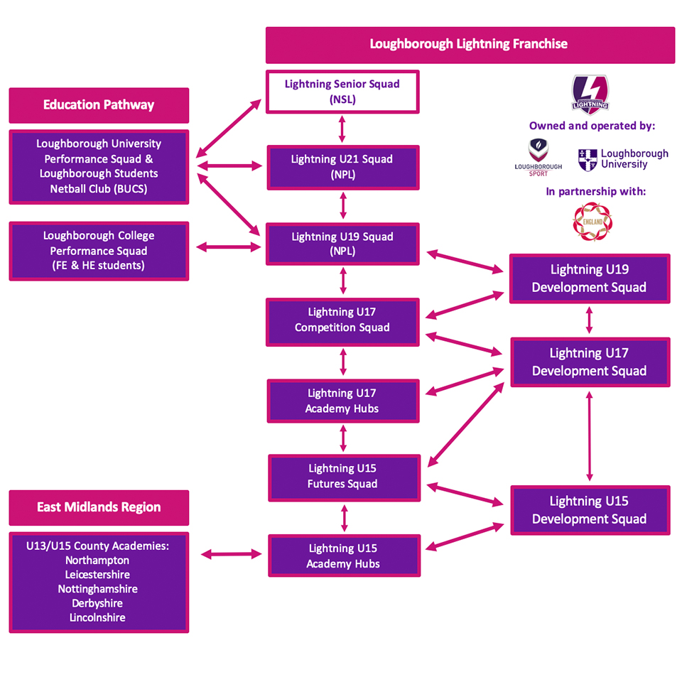

A List of the Loughborough Lightning Players and the NSL Squads from the start season are shown below.
LOUGHBOROUGH LIGHTNING PLAYER NUMBERS
# | 2005 - 2006 | Additional Notes
1 | Olivia Murphy | C
2 | Karen Atkinson | VC
3 | Alex Astle
4 | Ama Agbeze
5 | Jade Clarke
6 | Laura Brown
7 | Lisa Stephenson
8 | Rebecca James
9 | Charlotte O'Neill
10 | Hannah Reid
11 | Jo Munnion
12 | Sarah Penny
13 | Vicky Percy
14 | Gemma Wiseman
15 | Leanne Badmin
# | 2006-2007 | Additional Notes
 | Olivia Murphy | C
 | Alex Astle
 | Rebecca James
 | Lisa Stephenson
 | Charlotte O'Neill
 | Jade Clarke | VC
 | Vicky Percy
 | Hannah Reid
 | Sarah Penny
 | Ama Agbeze
16 | Kara Luck
17 | Natasha Hampshire
18 | Verona Tomlin
19 | Kate Murphy
20 | Heather Clark
21 | Lauren Doyle
# | 2007-2008 | Additional Notes
 | Olivia Murphy | player coach
 | Charlotte O'Neill | C
 | Jade Clarke
 | Rebecca James
 | Lisa Stephenson
 | Verona Tomlin
 | Heather Clark
 | Alex Astle
 | Hannah Reid
 | Vicky Percy
 | Sarah Penny
 | Ama Agbeze
 | Natasha Hampshire
 | Kara Luck
 | Lisa Stephenson
 | Kate Murphy
22 | Jo Harten
# | 2008-2009 | Additional Notes
 | Olivia Murphy | player coach
 | Jade Clarke | C
 | Lisa Stephenson
 | Jo Harten
 | Natasha Hampshire
 | Hannah Reid
 | Kara Luck
23 | Alex Kirk
24 | Emma Bliss
25 | Becky Gentle
26 | Katy Rose
27 | Sarah-Jane O'Sullivan
28 | Nia Campbell-Watson
29 | Rachel Sharrod
# | 2009-2010 | Additional Notes
 | Jo Harten
 | Sarah-Jane O'Sullivan
 | Rebecca James
 | Alex Kirk
 | Katy Rose
 | Becky Gentle
 | Emma Bliss
 | Kara Luck
 | Leanne Badmin
30 | Layla Guscoth
31 | Masego Motaung
34
32 | Jade Forbes-Wattley
33 | Rebecca White
34 | Tallisa Haynes
# | 2010-2011 | Additional Notes
 | Olivia Murphy | player coach
 | Jo Harten
 | Tallisa Haynes
 | Sarah-Jane O'Sullivan
 | Becky James
 | Emma bliss
 | Becky Gentle
 | Leanne Badmin
 | Jade Forbes-Wattley
35 | Afrika Morris
36 | Alex Sinclair
37 | Michaella McFarlane
38 | Nicola Caunt
39 | Sophia Candappa
# | 2011-2012 | Additional Notes
 | Leanne Badmin
 | Rebecca James | C
 | Nicola Caunt
 | Sophia Candappa
 | Michaella McFarlane
 | Jade Forbes-Wattley
 | Afrika Morris
 | Alex Sinclair
40 | Jodie Gibson
41 | Olivia Mason
42 | Jenny Montgomery
43 | Jordan Moxey
44 | Lauren Steadman
45 | Lucy Adams
# | 2012-2013 | Additional Notes
 | Olivia Mason
 | Masego Motaung
 | Sophia Candappa | C
 | Afrika Morris
 | Jade Forbes-Wattley
 | Lauren Steadman | VC
 | Jodie Gibson
 | Nicola Caunt
46 | Hannah Joseph
47 | Nikita Piggott
48 | Vanessa Walker
49 | Fran Desmond
50 | Lauren Massey
51 | Beth Payne
52 | Florence Edwards
53 | Rachel Malloy
# | 2013-2014 | Additional Notes
 | Hannah Joseph
 | Lauren Steadman | C
 | Florence Edwards
 | Lauren Massey
 | Rebecca James
 | Nicola Caunt
 | Olivia Mason
 | Fran Desmond
54 | Elizabeth Hayman
55 | Jesse Waitapu | C
56 | Moneik Van Rossum
57 | Holly Sims
58 | Rochelle Powell
59 | Eleanor Durcan
60 | Emily Watson
61 | Neala Brennan
# | 2014-2015 | Additional Notes
 | Florence Edwards
 | Fran Desmond
 | Hannah Joseph
 | Olivia Mason
 | Lauren Massey
 | Lauren Steadman
 | Vanessa Walker
62 | Maryka Holtzhausen
63 | Peace Proscovia
64 | Phumza Maweni
65 | Rachel Forbes
66 | Rachel Henry | C
67 | Niamh Cooper
68 | Rebekah Airey
69 | Sophie Masterson
# | 2015-2016 | Additional Notes
 | Hannah Joseph
 | Peace Proscovia
 | Rebekah Airey
 | Ama Agbeze
 | Jade Clarke | C
 | Lauren Massey
 | Lauren Steadman
 | Olivia Mason
70 | Jo Trip
71 | Kadeen Corbin
72 | Natalie Panagarry
73 | Sasha Corbin
74 | Rachel Sweet
75 | Brittany Coleman
76 | Hariett Gill
# | 2016-2017 | Additional Notes
 | Peace Proscovia
 | Jo Trip
 | Natalie Panagarry | C
 | Hannah Joseph
 | Rebekah Airey
 | Brittany Coleman
 | Olivia Mason
 | Vanessa Walker
77 | Beth Cobden
78 | Ella Clark
79 | Ella Gibbons
80 | Vicki Oyesola
81 | Caroline Tarnowski
82 | Chloe Essam
83 | Rosie Harris
# | 2017-2018 | Additional Notes
 | Natalie Panagarry | C
 | Hannah Joseph
 | Rebekah Airey
 | Ella Clark
 | Chloe Essam
 | Rosie Harris
 | Vicki Oyesola
 | Peace Proscovia
 | Brittany Coleman
 | Lauren Nicholls (nee Steadman)
84 | Brie Grierson
85 | Shamera Sterling
86 | Anya Wood
87 | Suzie Armstrong
# | 2018-2019 | Additional Notes
 | Natalie Panagarry | C
 | Hannah Joseph
 | Ella Clark
 | Vicki Oyesola
 | Brittany Coleman
 | Rosie Harris
 | Caroline Tarnowski
88 | Jess Shaw
89 | Mary Cholhok
90 | Tuaine Keenan
91 | Lucy Parize
92 | Zara Everitt
93 | Amy Clinton
94 | Annabel Roddy
95 | Emily Hollingworth
# | 2019-2020 | Additional Notes
 | Natalie Panagarry | C
 | Hannah Joseph
 | Ella Clark
 | Vicki Oyesola
 | Mary Cholhok
 | Jess Shaw
 | Lucy Parize
 | Annabel Roddy
 | Lauren Nicholls (nee Steadman)
96 | Sam May
97 | Jasmine Odeogberin
98 | Hannah Williams
99 | Alice Harvey
100 | Beth Gabriel
101 | Suzie Liverseidge

